Task on VPC Transit Gateway & VPC Endpoint
Create one VPC with public subnet and private subnet
Created a vpc in vpc section and named as mynewvpc
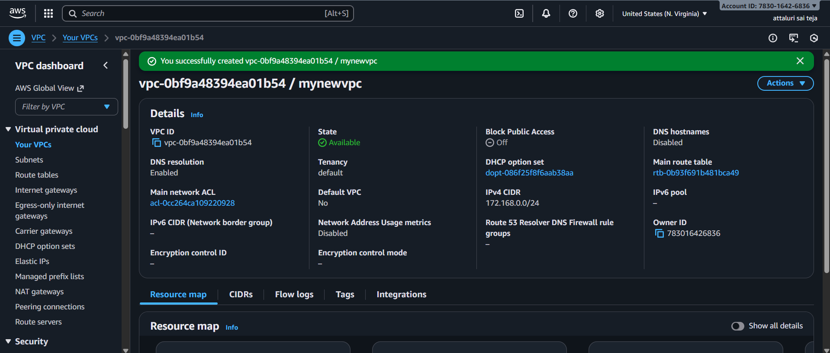
Creating subnets
Navigate to subnets section and select create subnet option
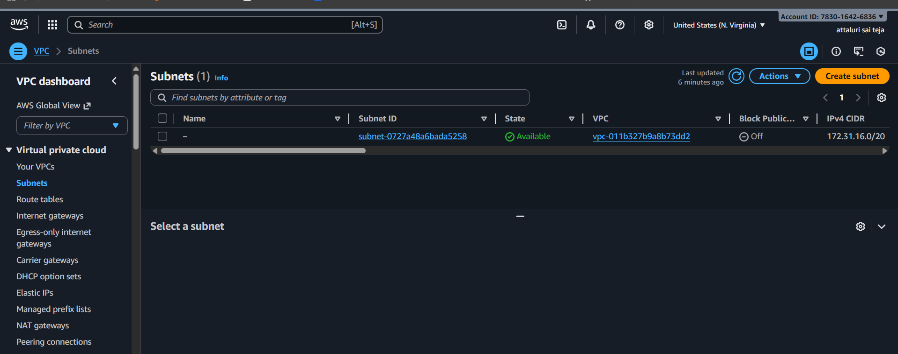
Select the vpc which you created
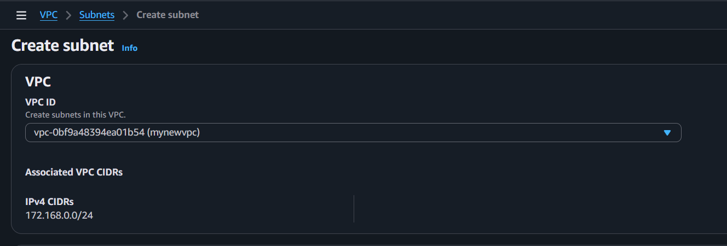
Creating a public subnet and named as public
Allocate the ip address without overlapping
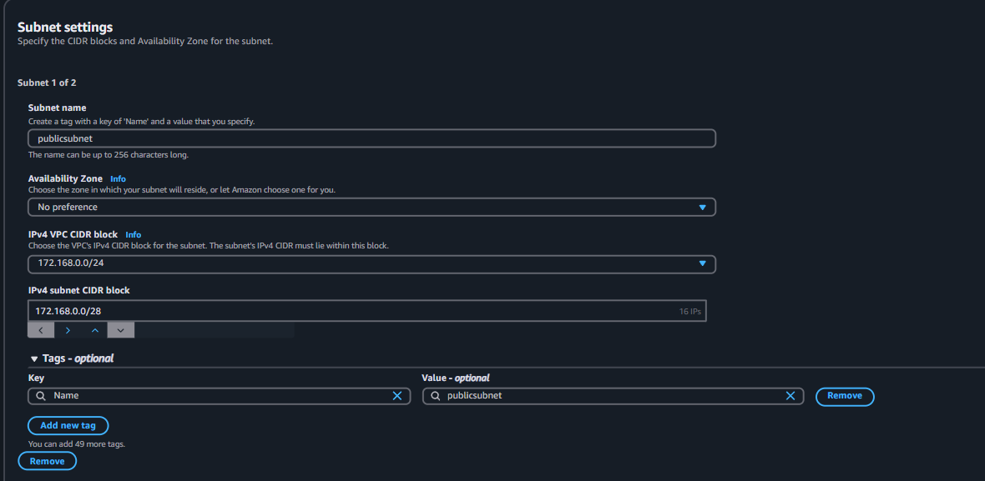
Created a private subnet and named as private subnet
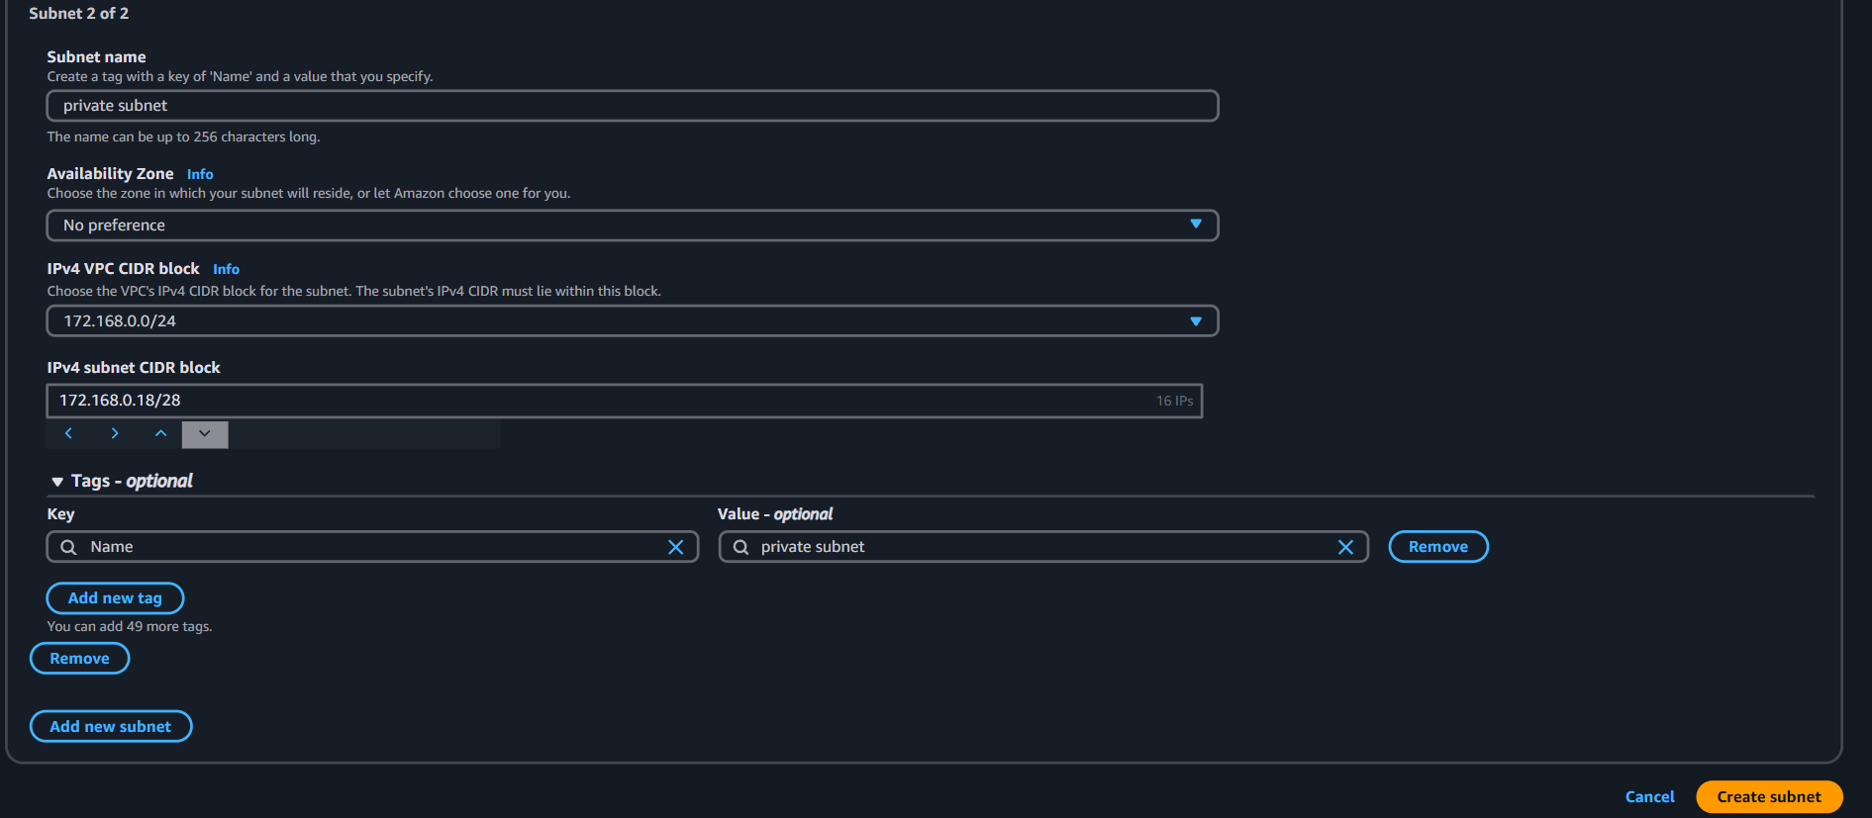
Both subnets were created
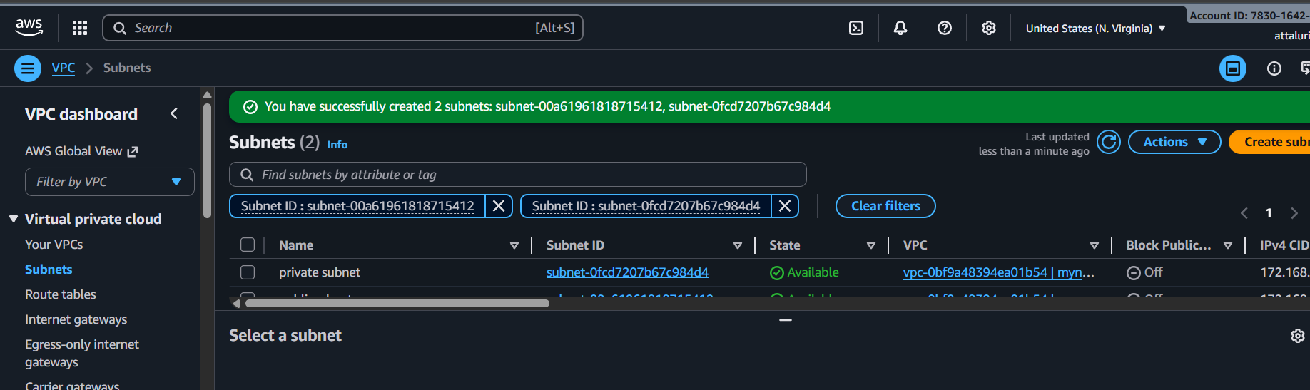
Enable VPC peering for cross-region.
- Subnets should be public only
- Igw should be created for both and attach to subnets
- Instances should be public only
- 2 Route table and 2 sg groups should be for 2 subnets
- Peering connection from vpc 1 to vpc 2
- Route table should consist peering connections and igw
- Through vpc 1 instance should be connected and pem key should be created and change pemissions to chmod 400
- Connect or check ping with vpc 2 private ip
One vpc is created in north virginia region
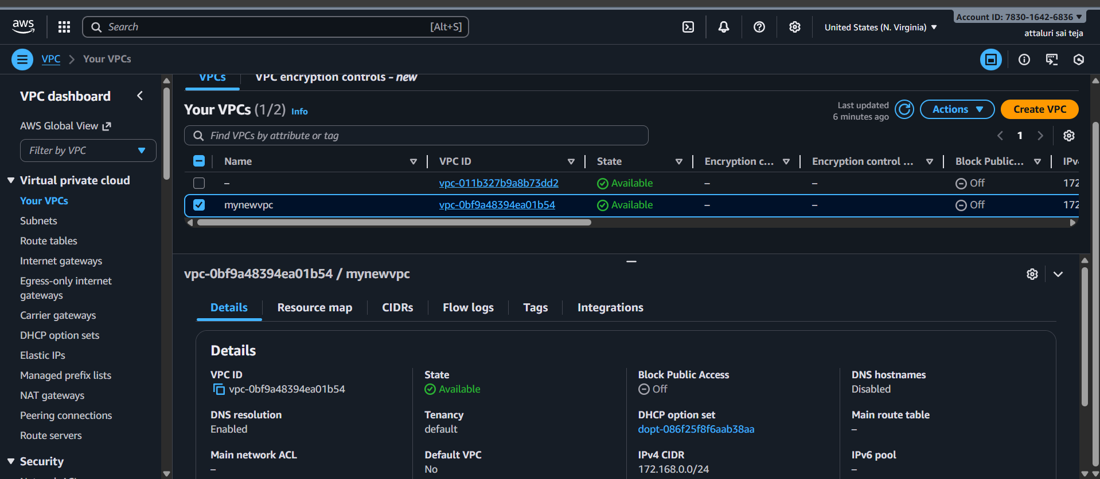
Another vpc is creating in ap-south-1
And providing another ip series for not overlapping
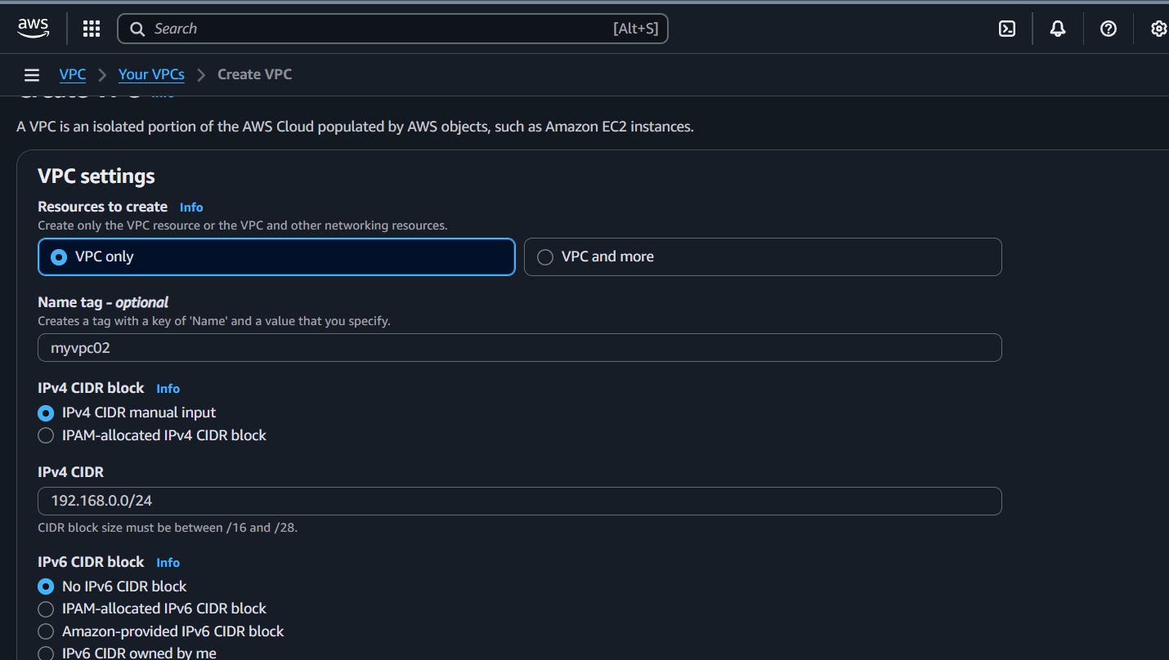
Vpc in another region is created
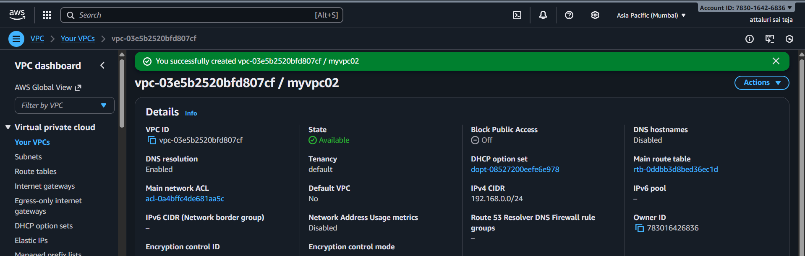

Moving to peering connections
Navigating to north virginia region and selecting peering connections tab and select create peering connections
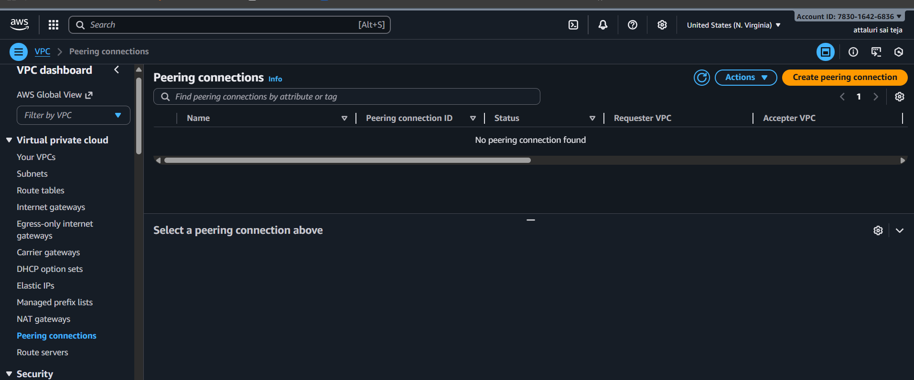

Enter the peering connection name and select your vpc id from that region and verify the ip address associated with and select my account option because the vpc’s are from same account but different region
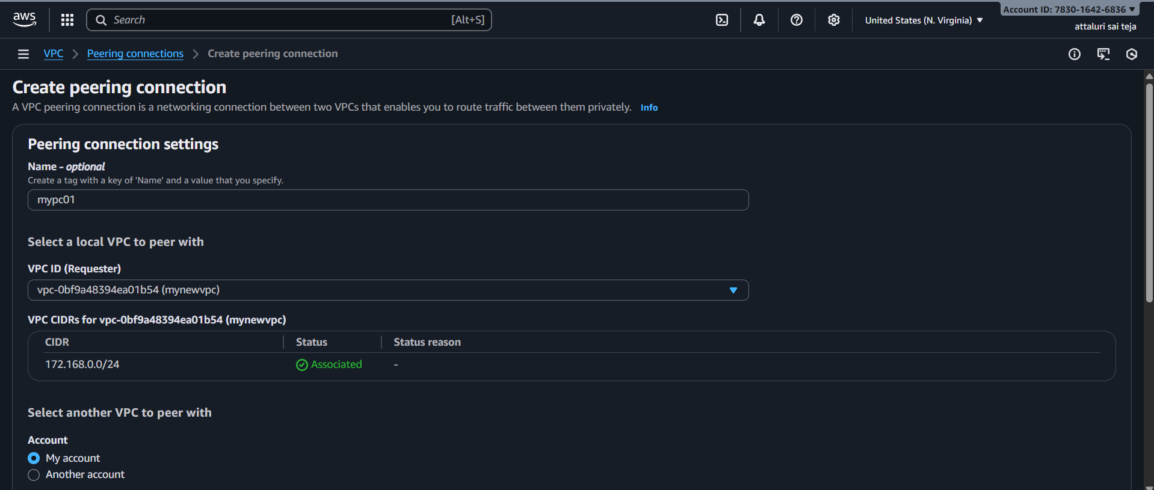
Then select the option another region for the reason your another vpc is from another region and copy paste the vpc and select region then click the option create
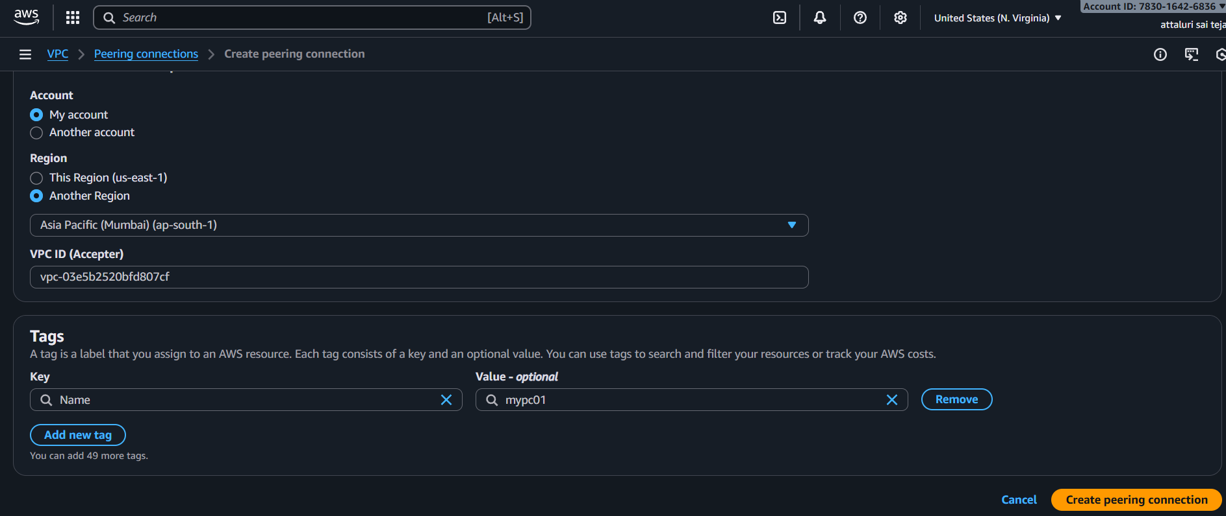

Peering request has been sent to another region vpc id and confirm it to access peering connections
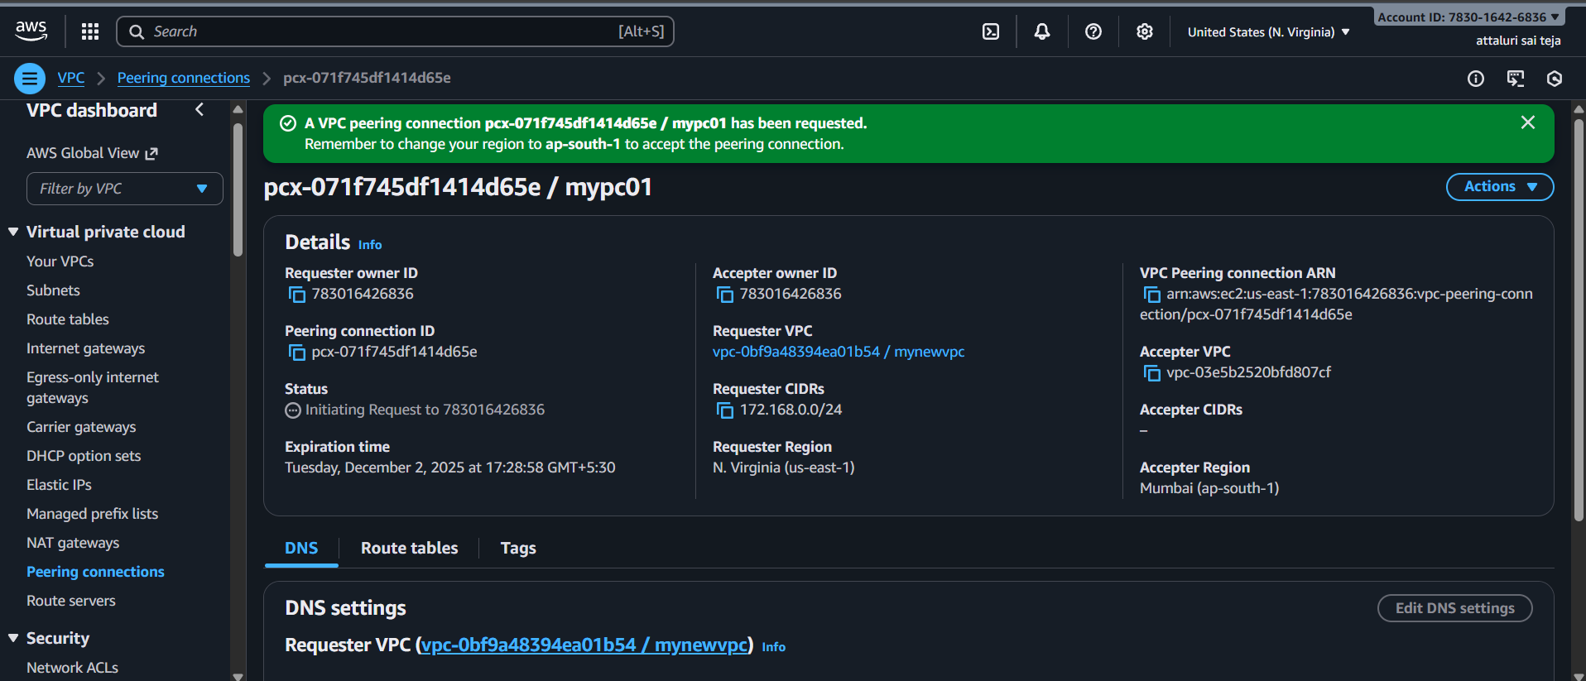
In another region in peering connection settings select action option to accept the request
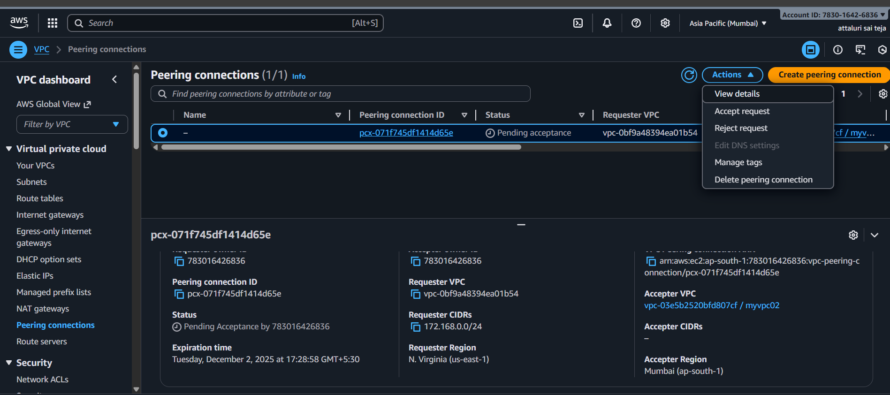
Confirm the details and accept
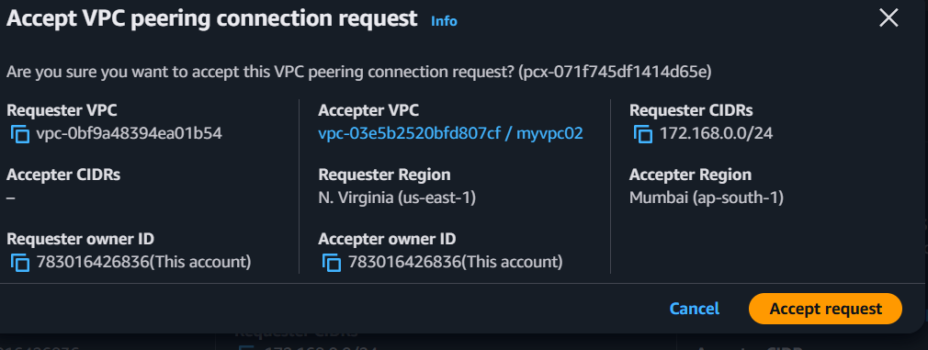
Vpc peering connections was established successfully
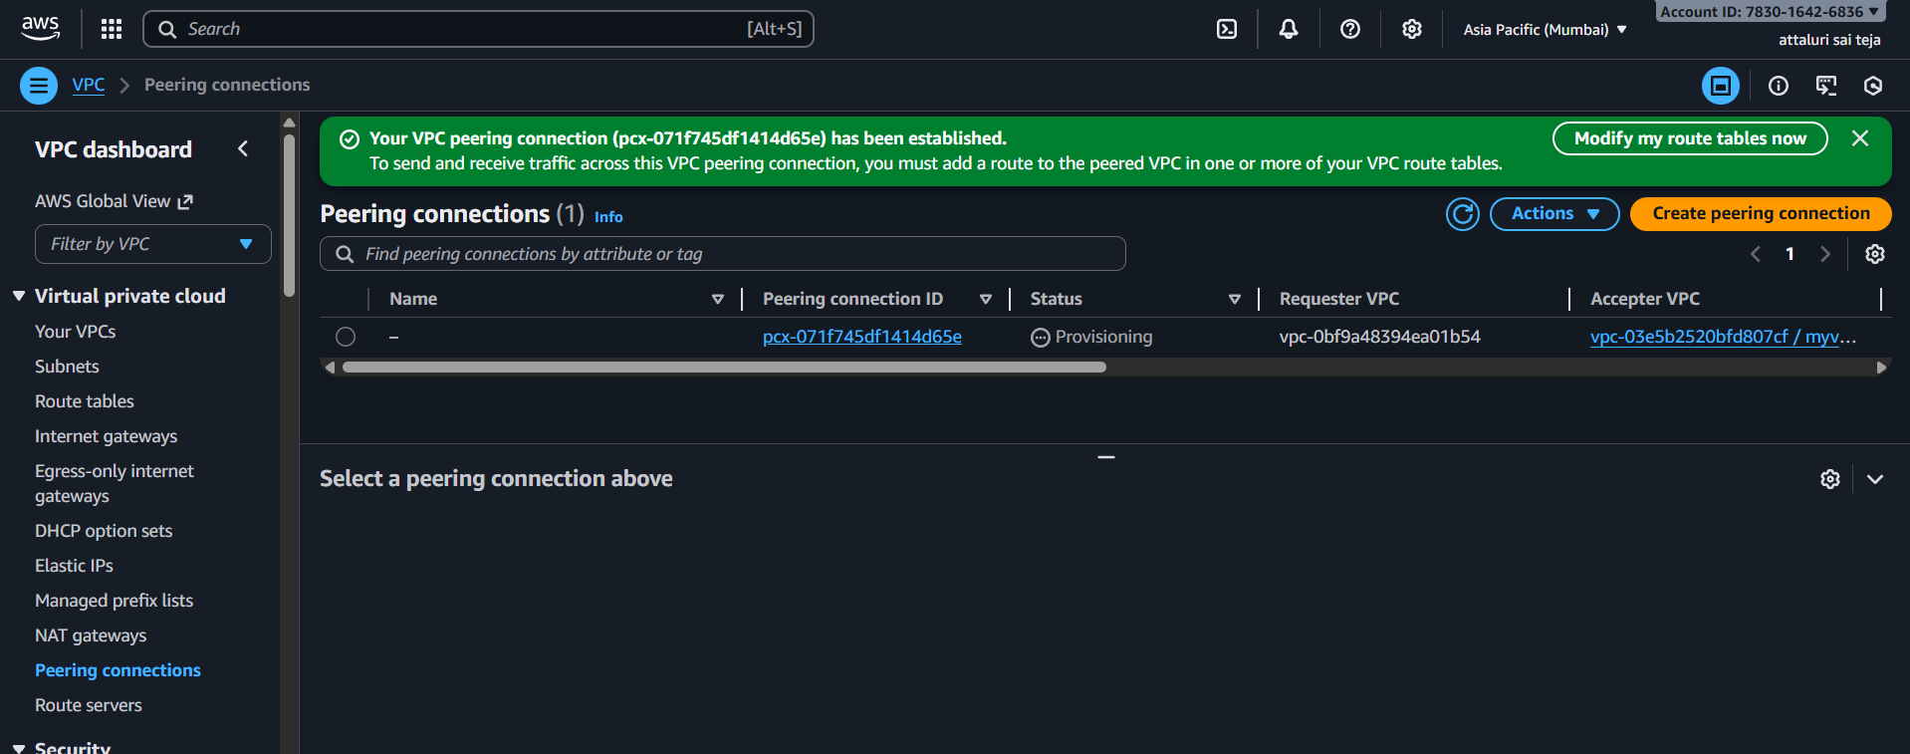
Select the option modify my route table now to create route table
Select the option routes and select edit routes
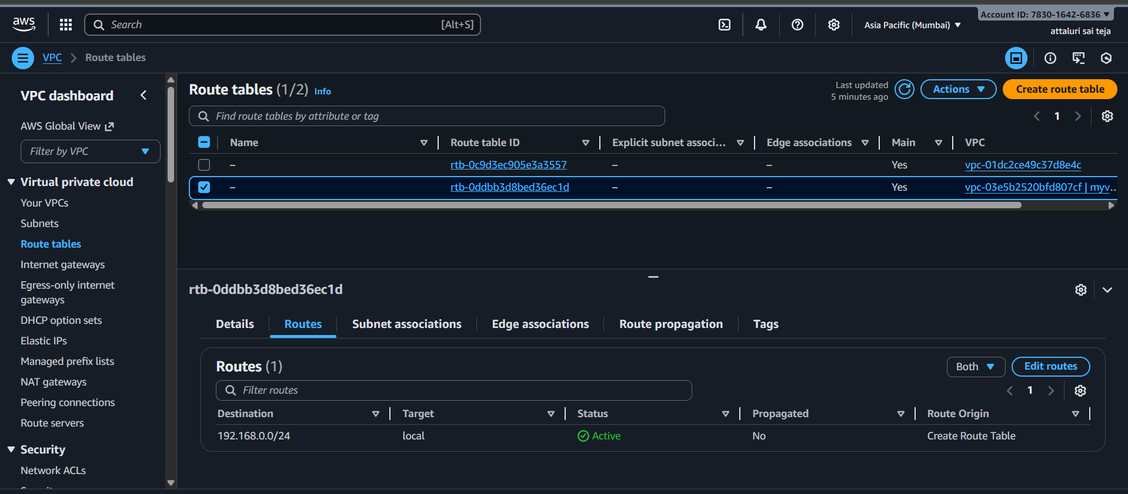

Select all ip and select peering connections and save
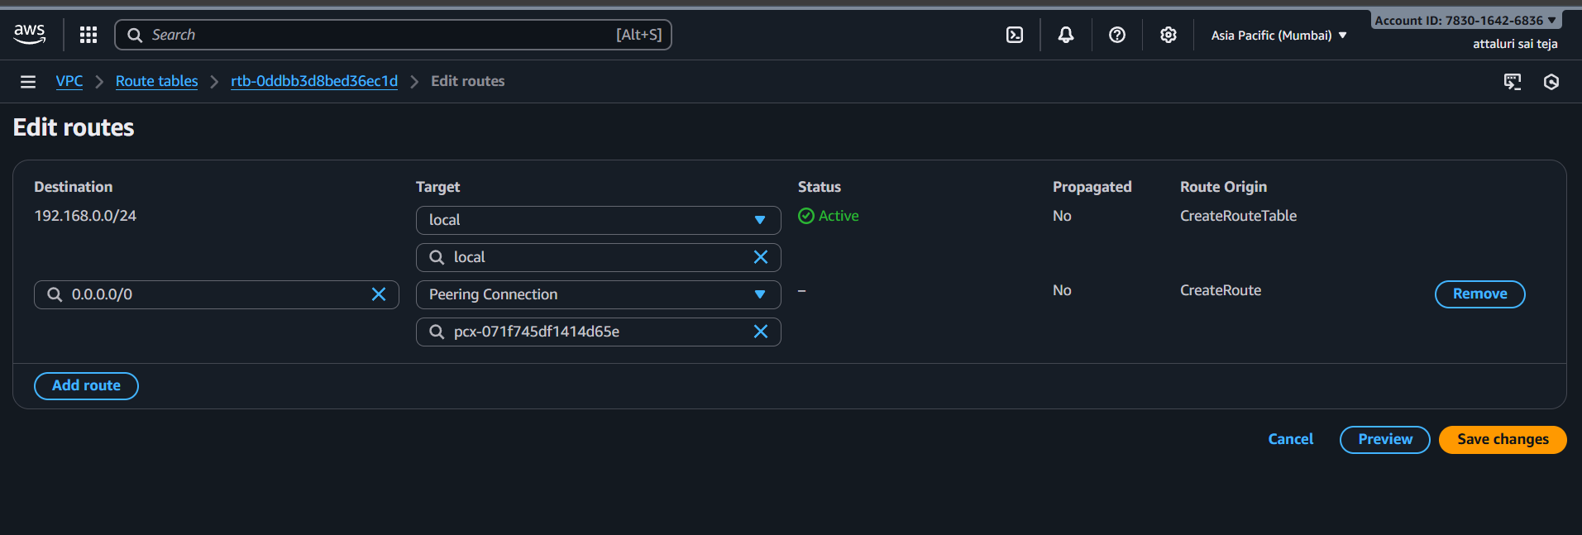

Route table has been updated successfully
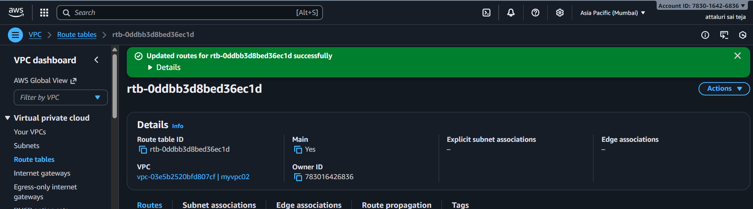

Do the same for another vpc
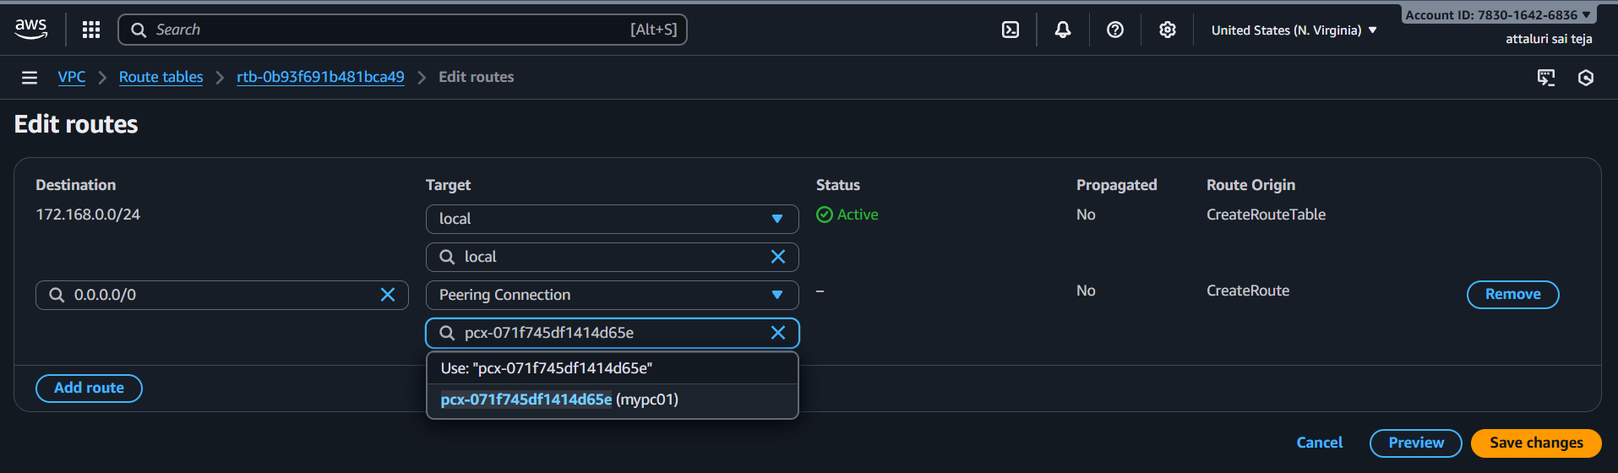

Routes has been configured
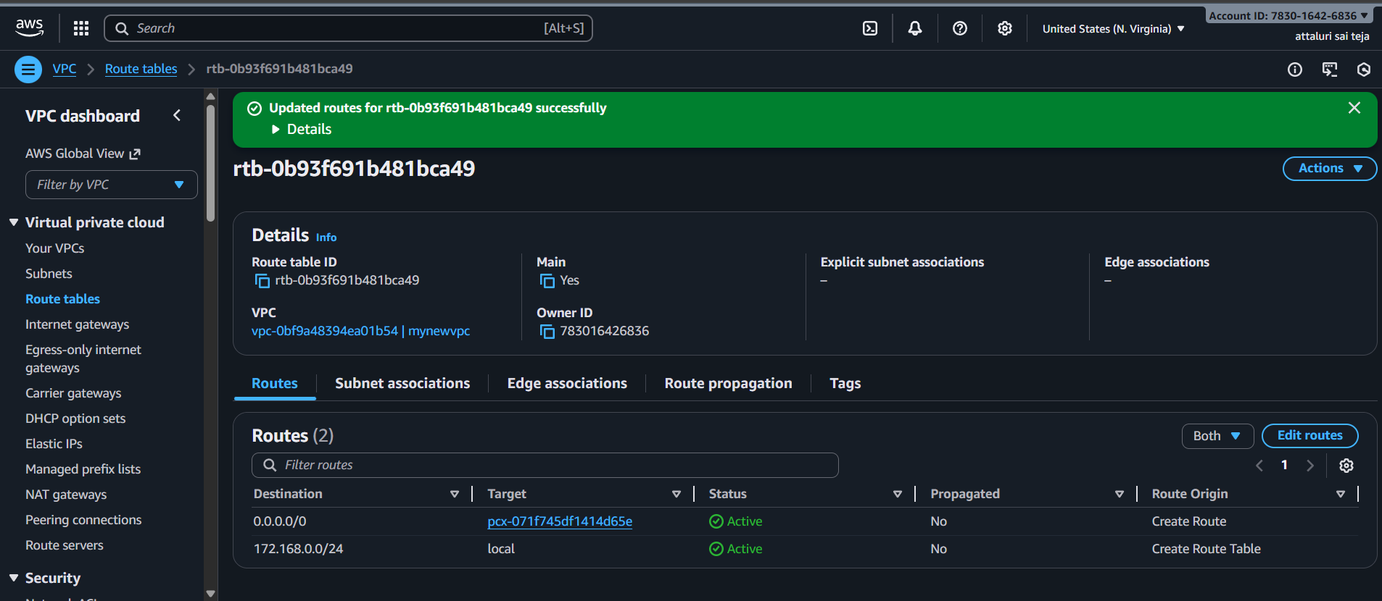

You can verify the details of both vpc’s and ip’s
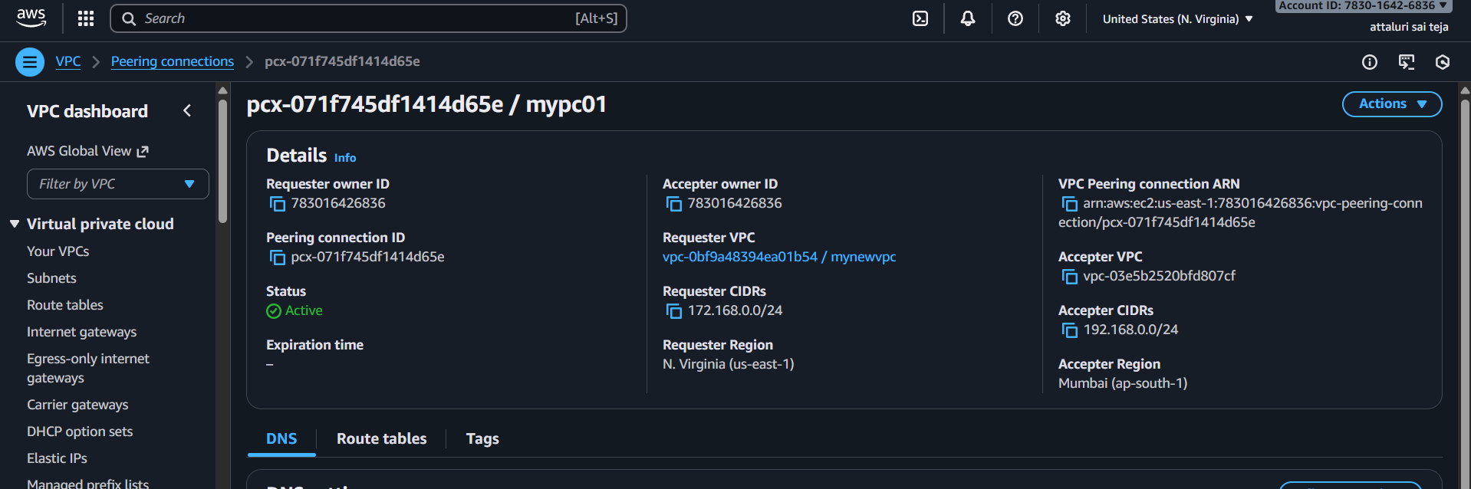
Navigate to security groups and allow to peering connections rules and check rules alltraffic or not in both vpc’s
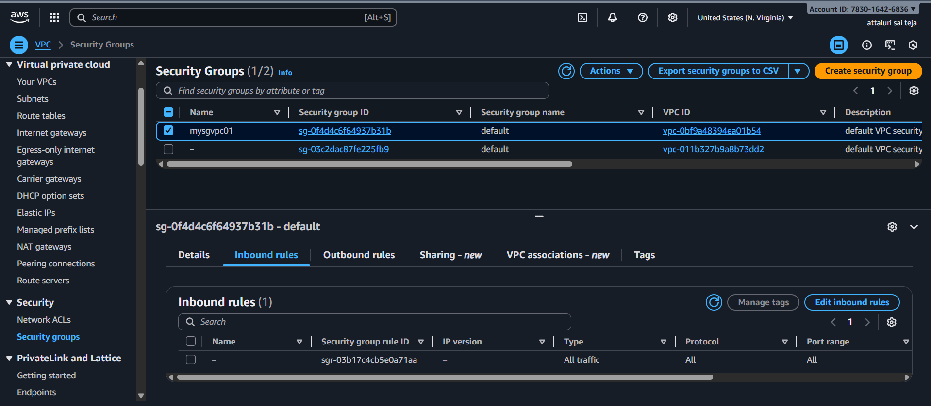
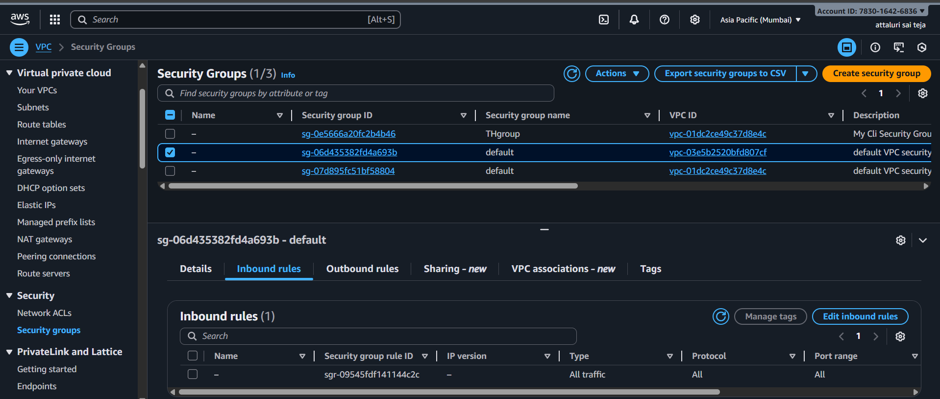
launch instances in public subnets within both VPCs.
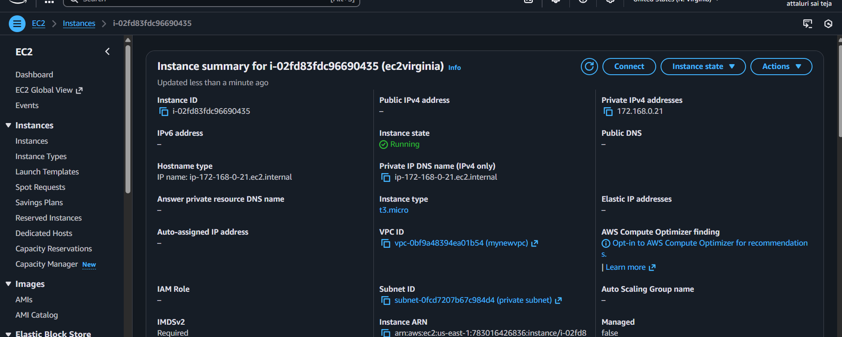
Create public subnet in another region
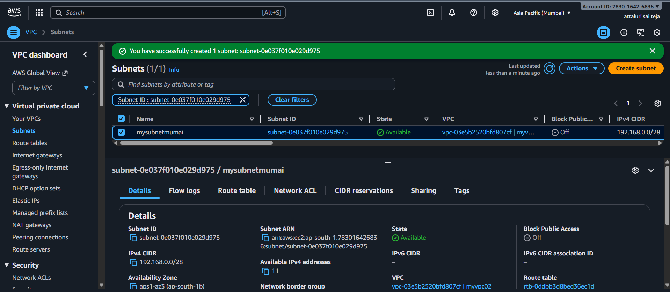

And launch instance in another region by selecting private subnet
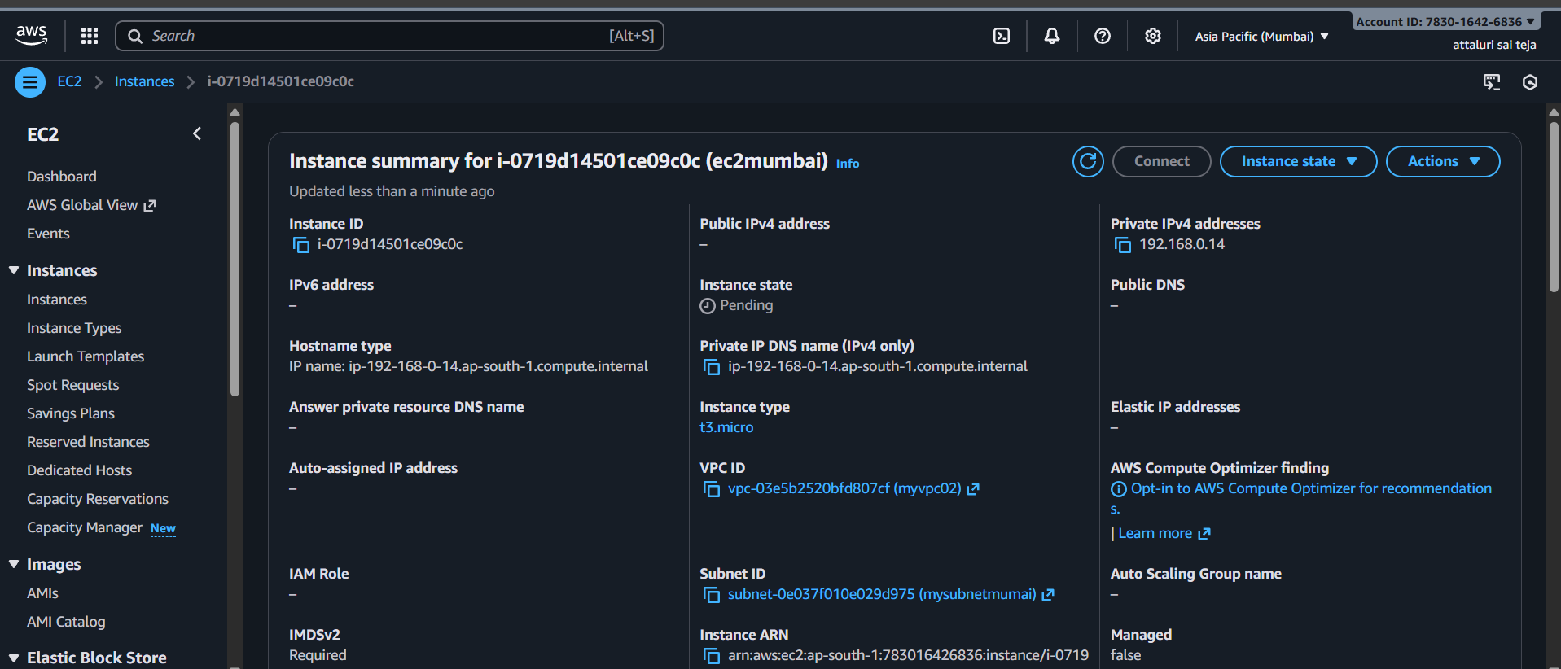
Connected in bash and verified
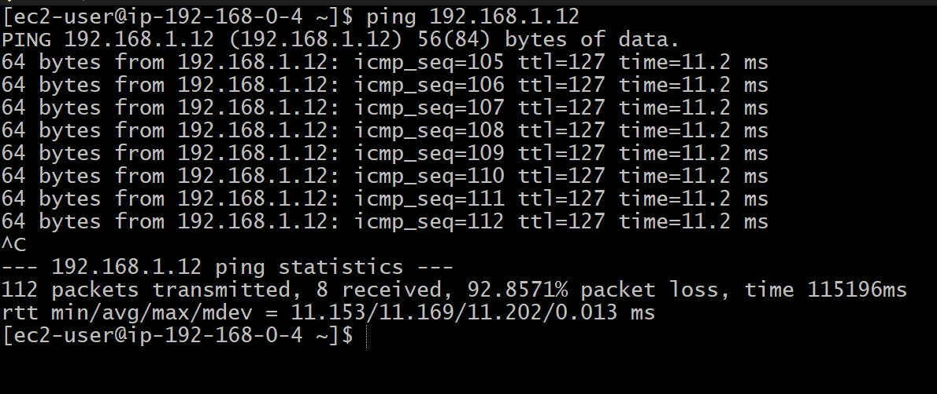

Enable VPC peering for cross-account (you can collaborate with your friend to do this task).
Requested a friend to collaborate and sent request
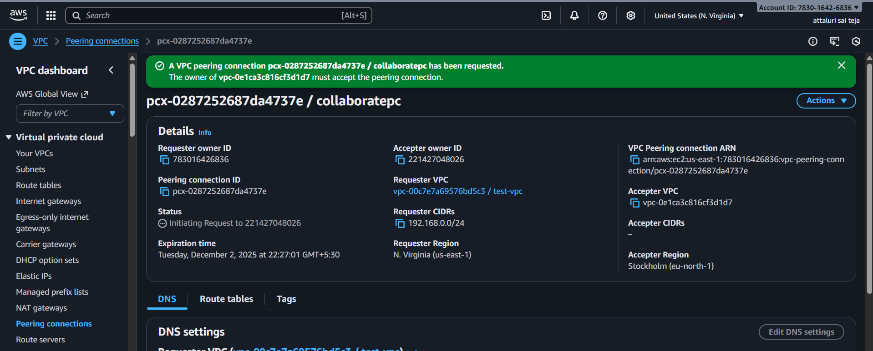
Change the security groups
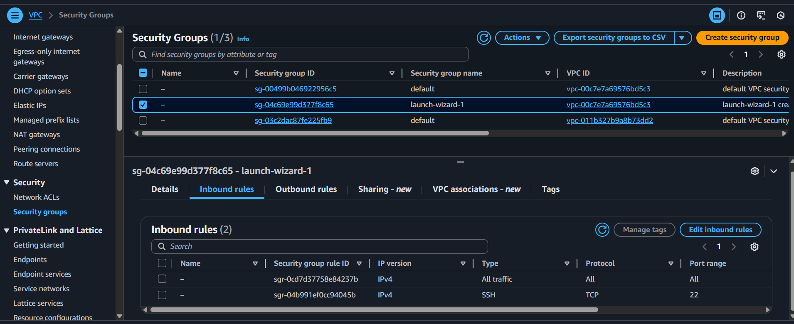
Change the route table
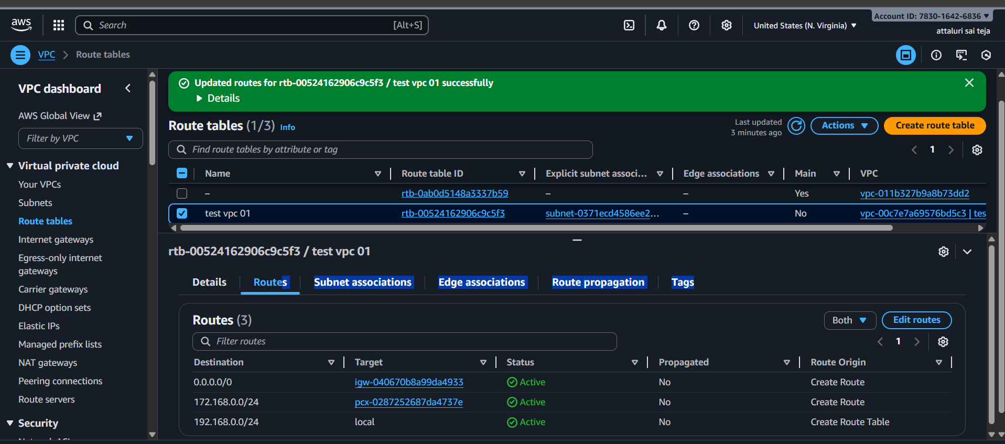
Verified using ping command
ping@his instance private ip
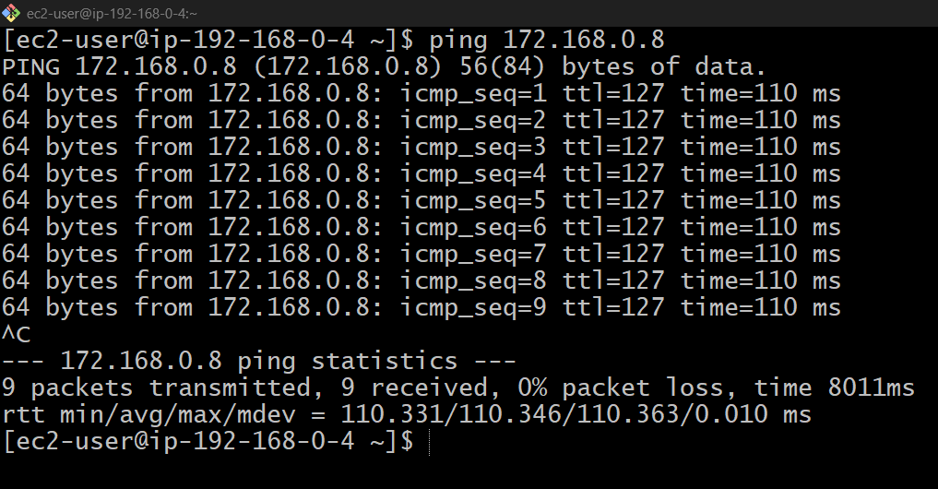
Process while he requested
Got a request in peering connections
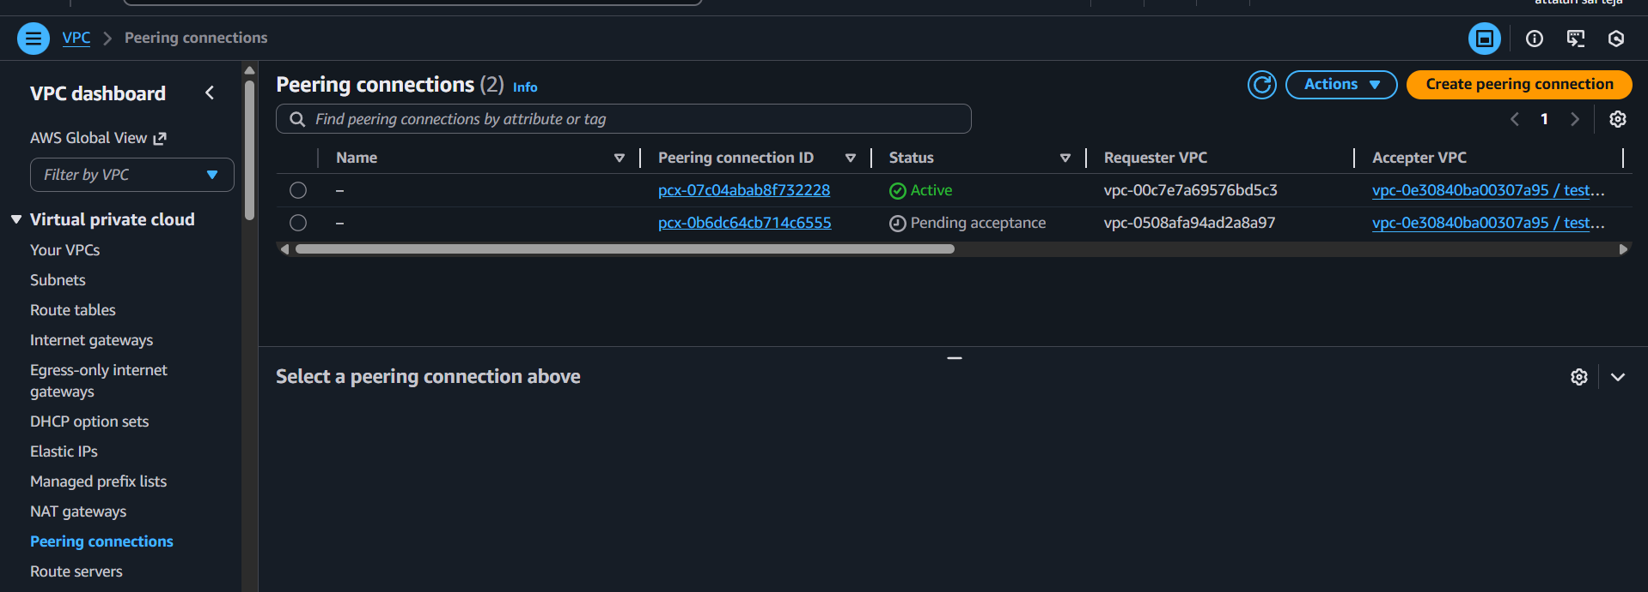
Accepted the request
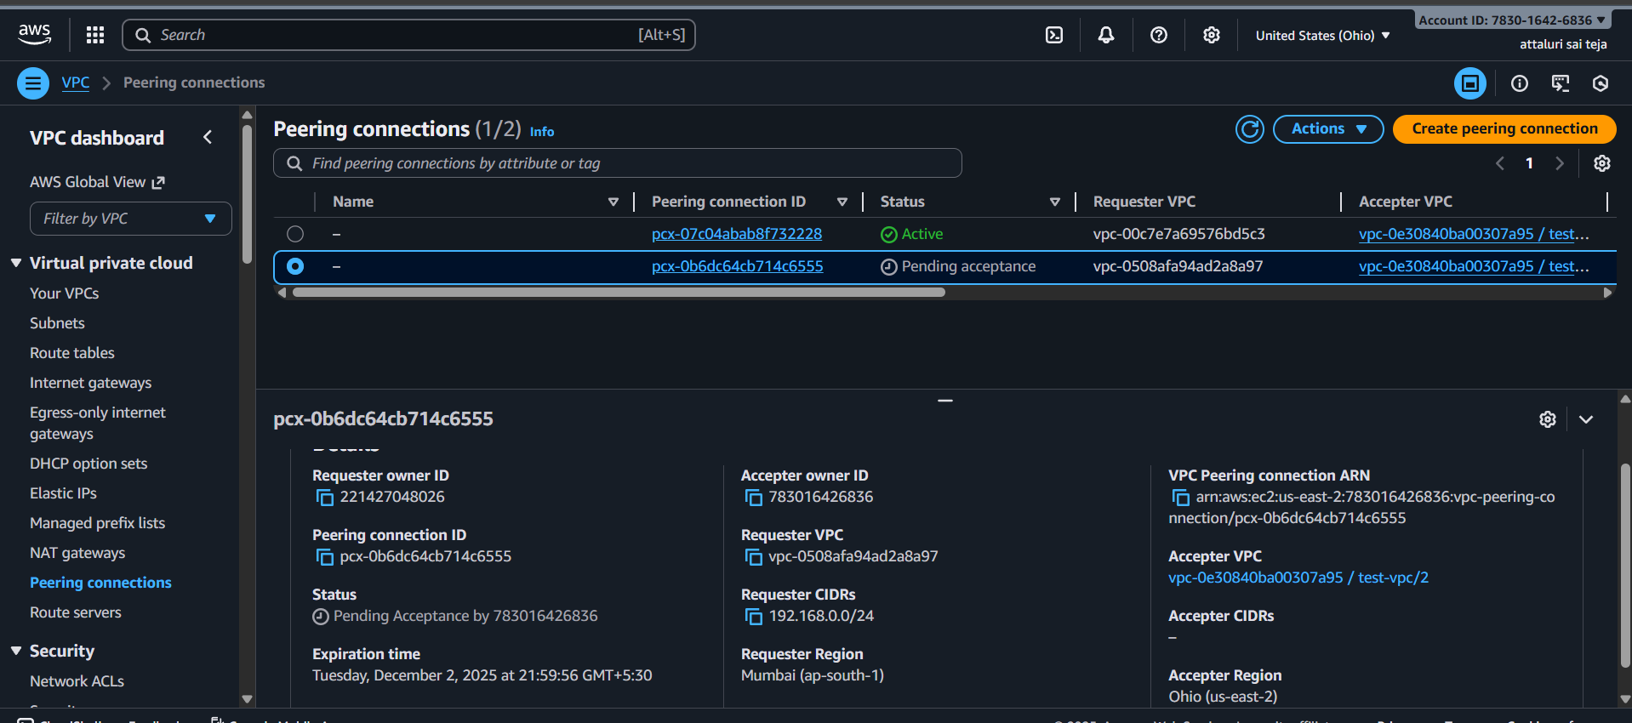
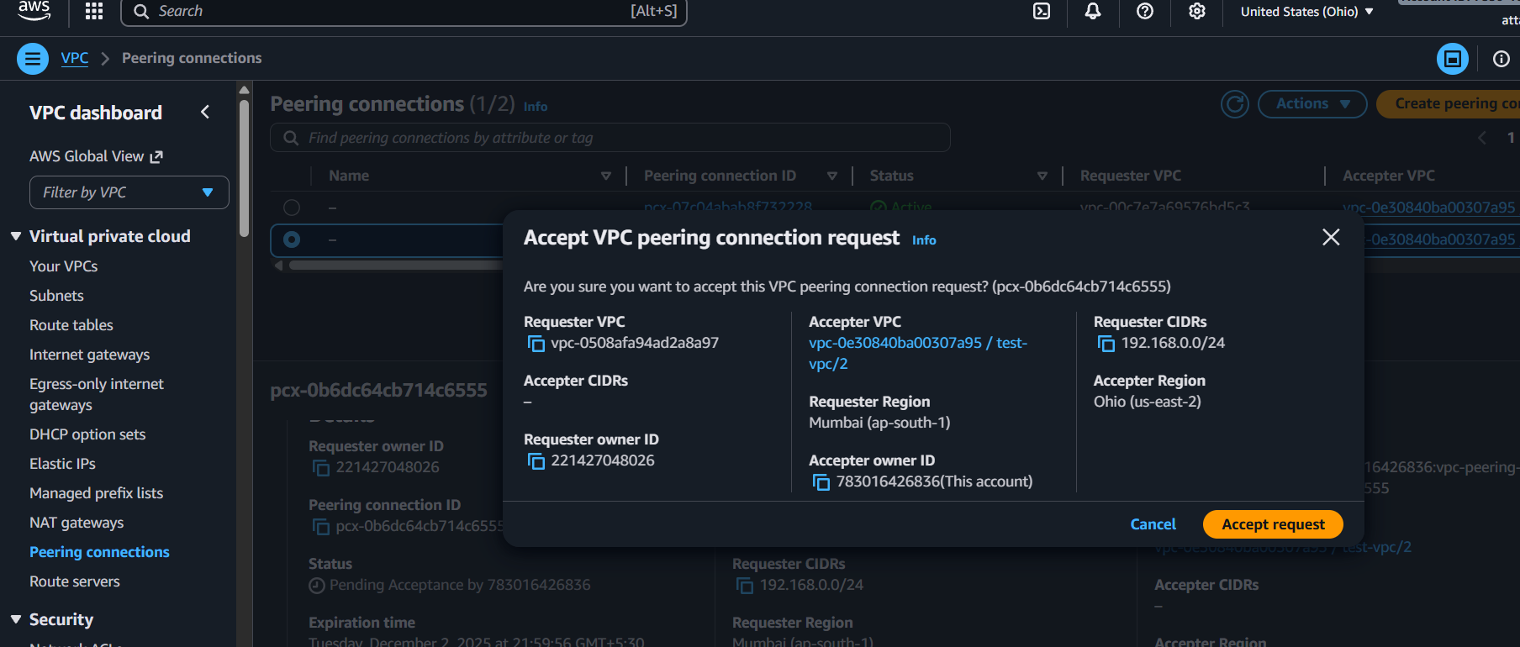

Modified the route table by adding his cidr range
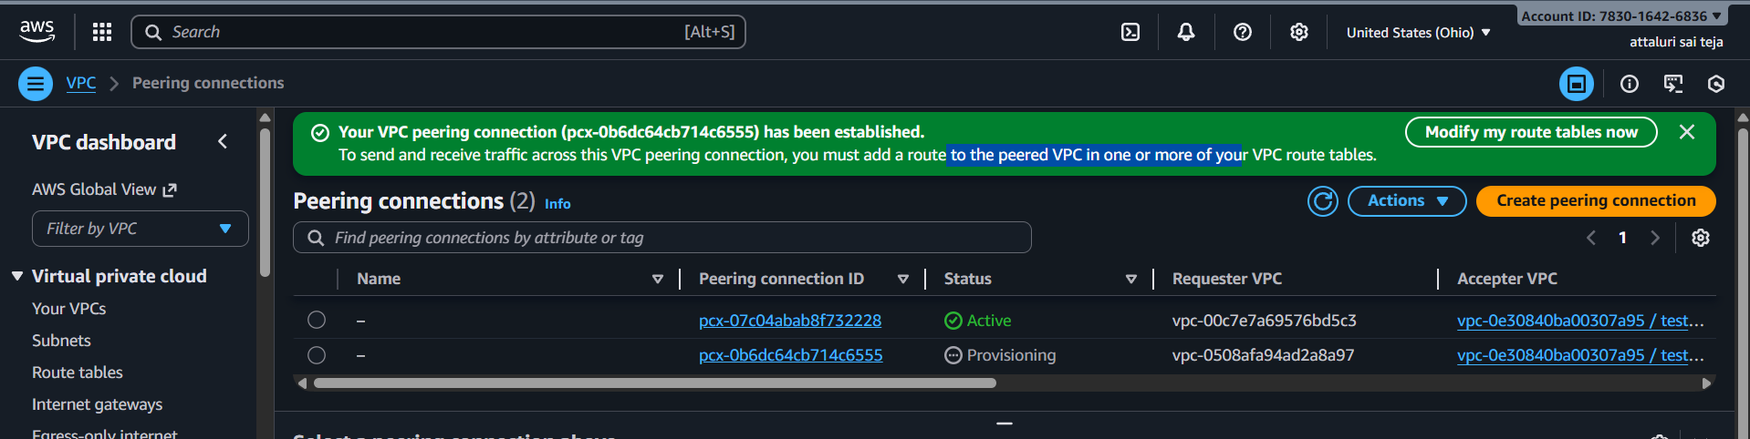
And verified
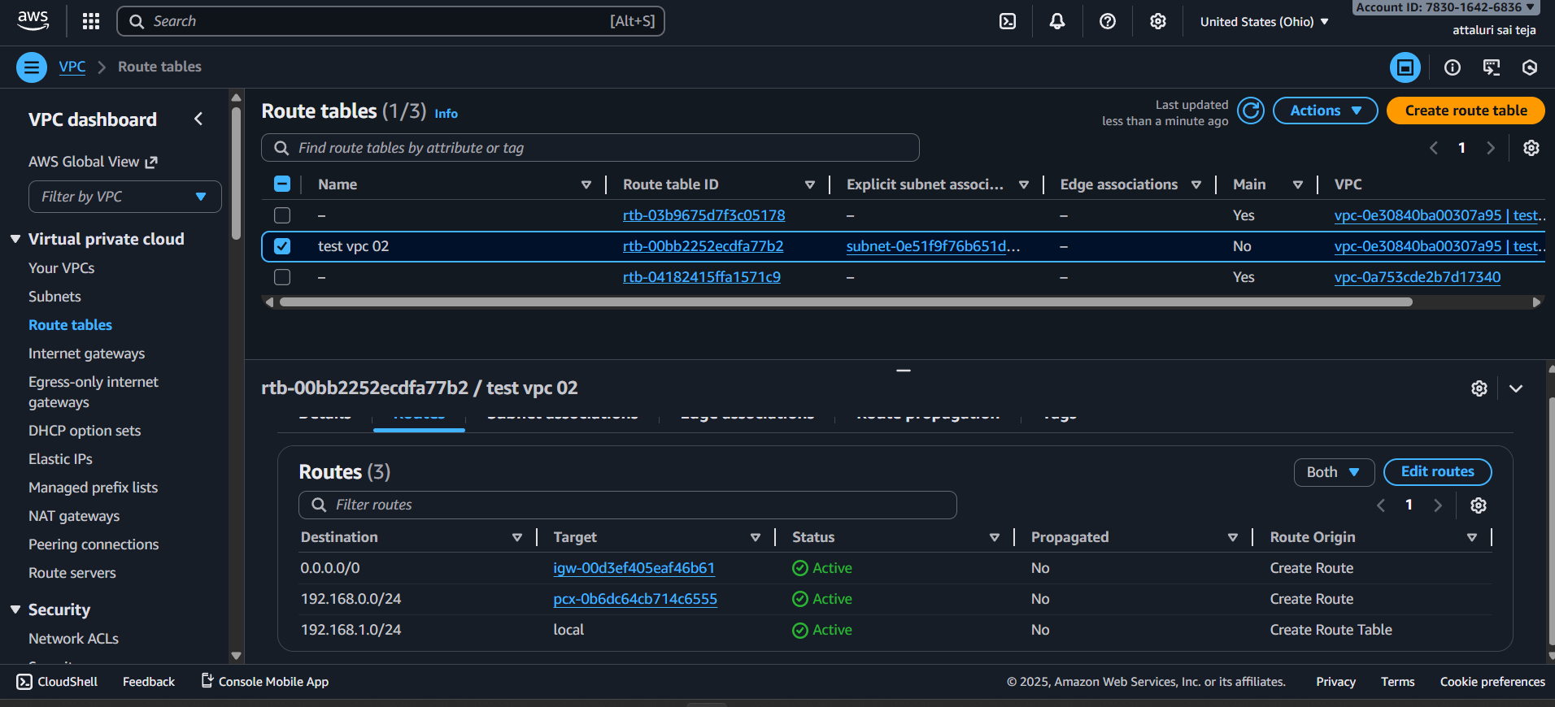

Set up a VPC Transit Gateway.
Step 1: Create Transit Gateway
- Navigate to Transit Gateway and click on Create transit gateways
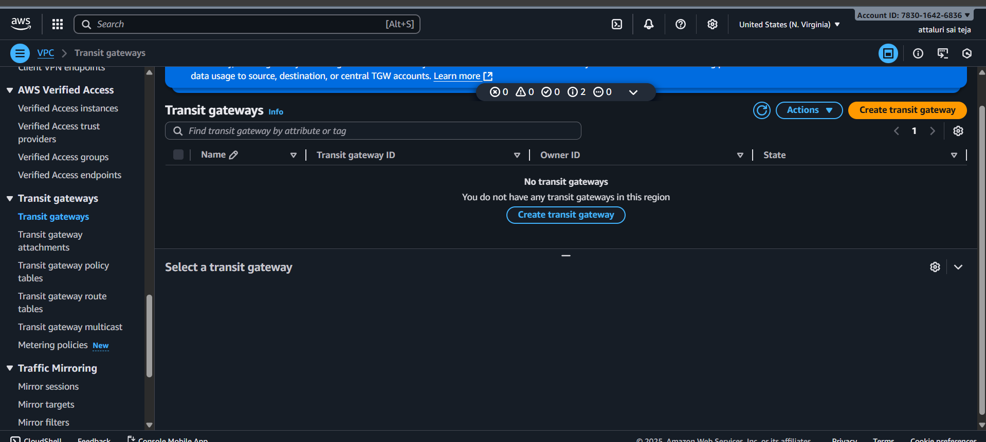
A transit gateway (TGW) is a network transit hub that interconnects attachments (VPCs and VPNs) within the same AWS account or across AWS accounts.
- Now click on create Transit Gateway
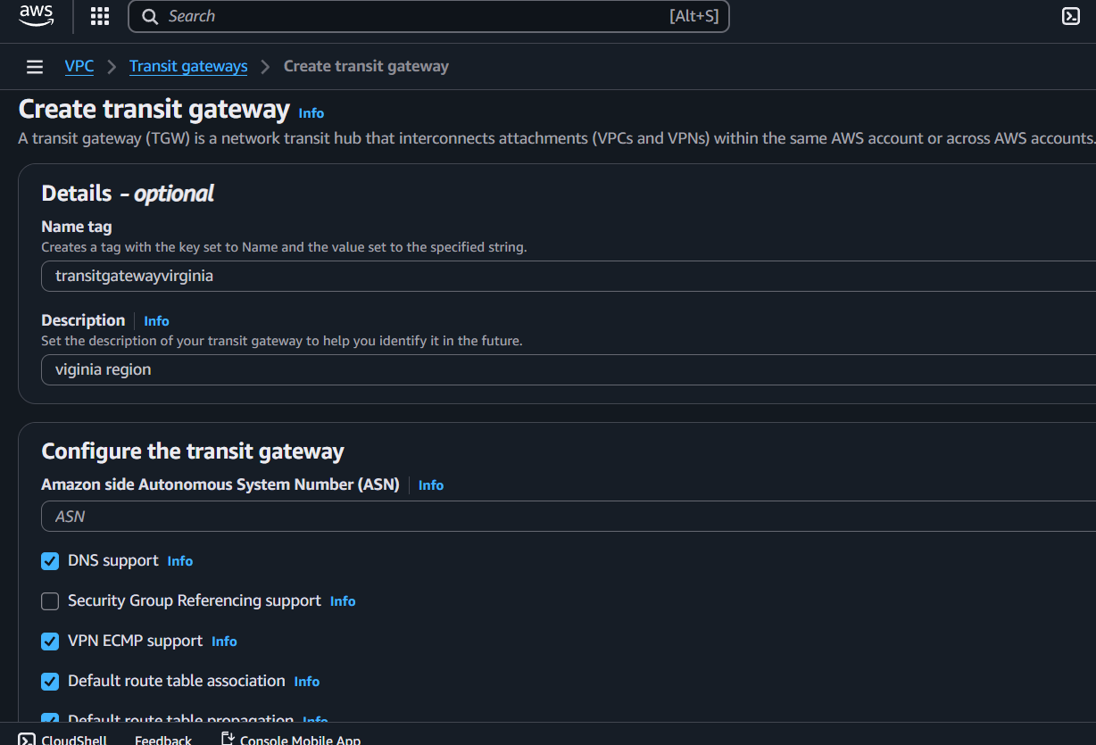

- Here we see transit gateway successfully created
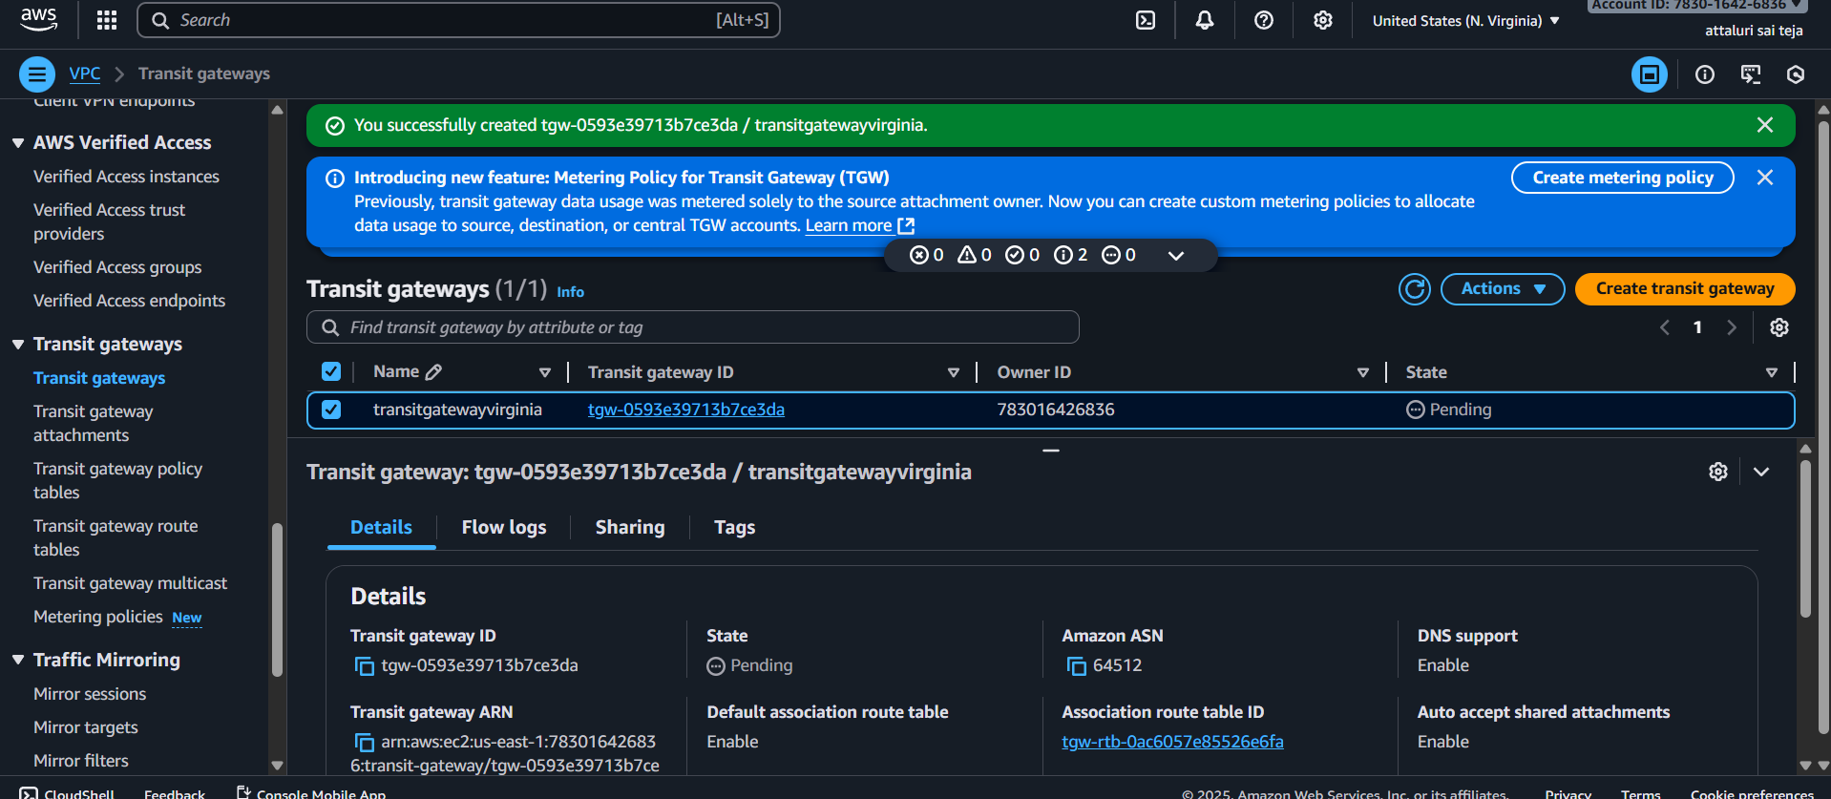
Step 2: Configuring VPCs
- Now create four VPCs or select existing VPCs.
- Navigate to VPC Dashboard and click on create vpc
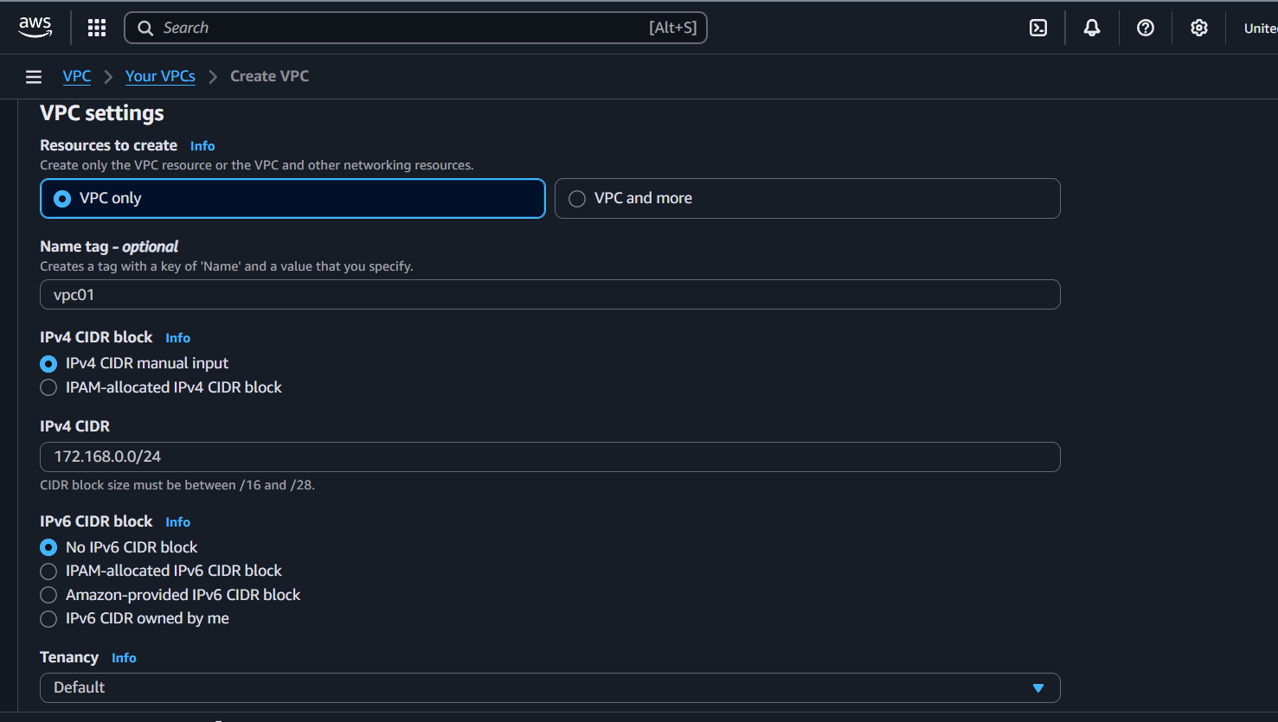

- Same process do for VPC2, VPC3 and VPC4.
- Here we see two VPC are created.
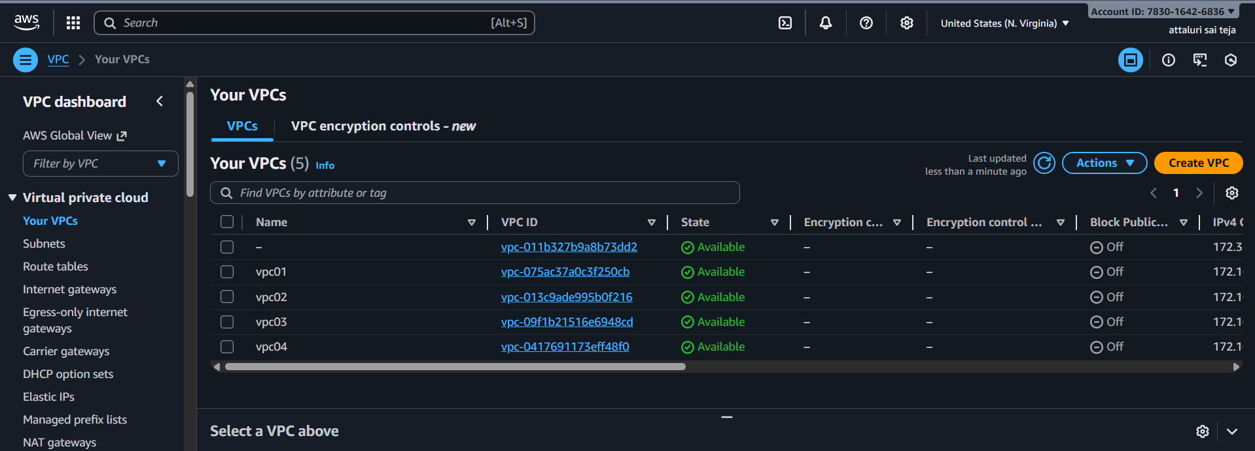
Step 3: create subnets
- Navigate to subnet section in vpc and click on create
- Do the same for each vpc
- We get around 4 subnets 1 for each
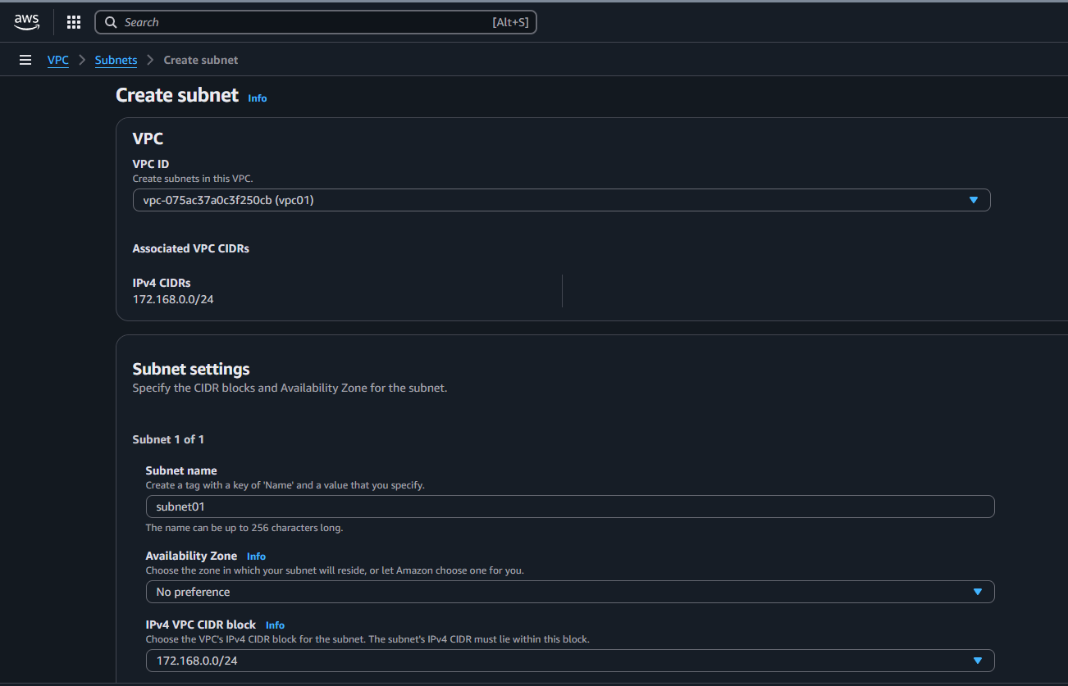

- Subnets have been created
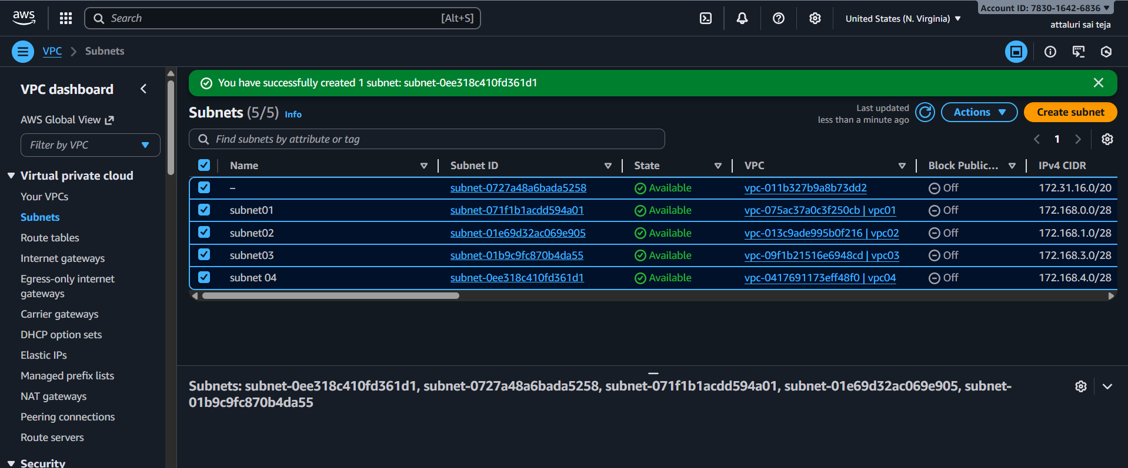

- Also create a Public subnet with VPC 02
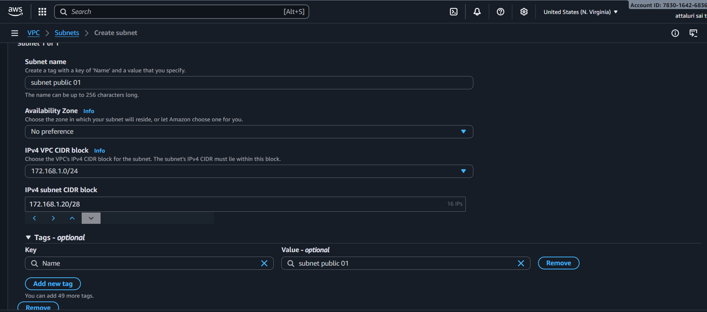
- Public Subnet Has been created
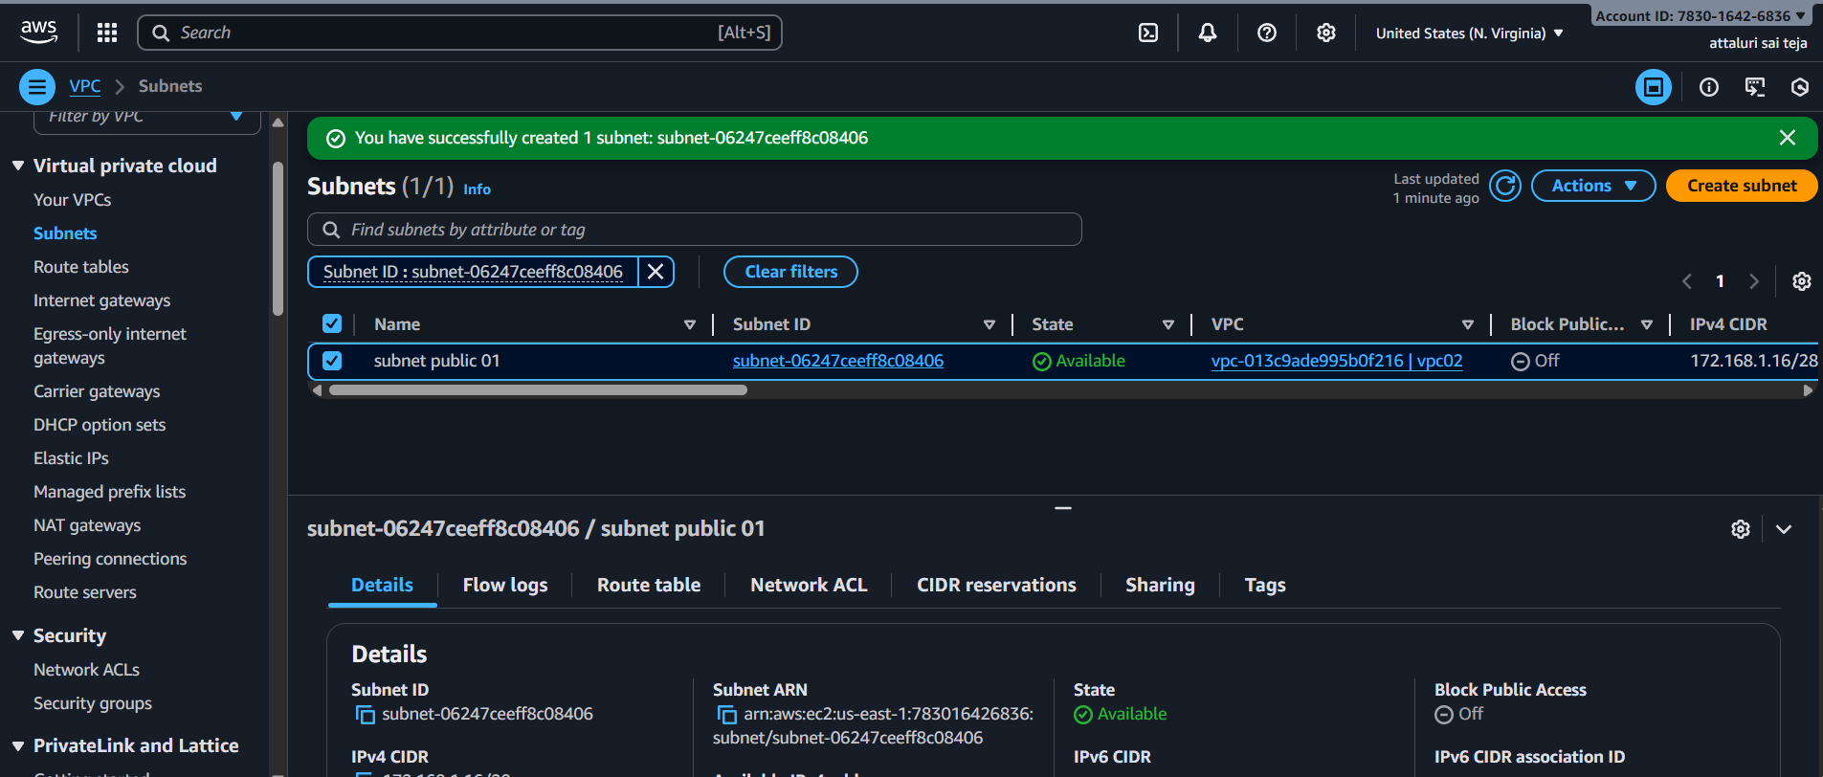
Step 4: create IGW
- Navigate to Internet Gateway Section and click on create internet gateway option
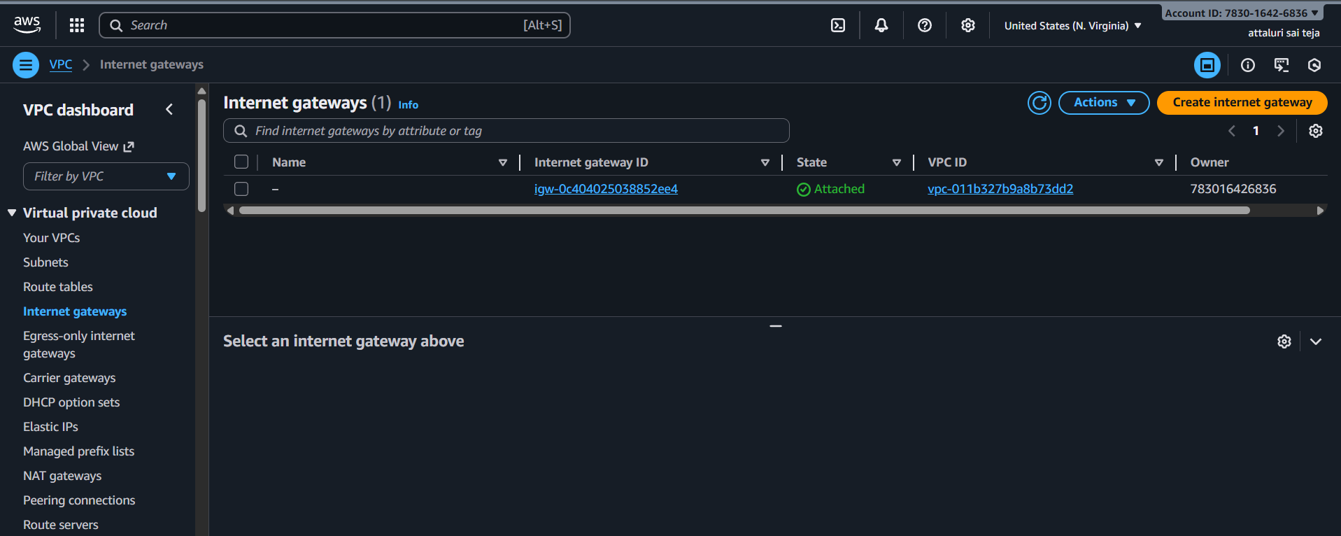
- Igw has been created
- Attach it to VPC 02
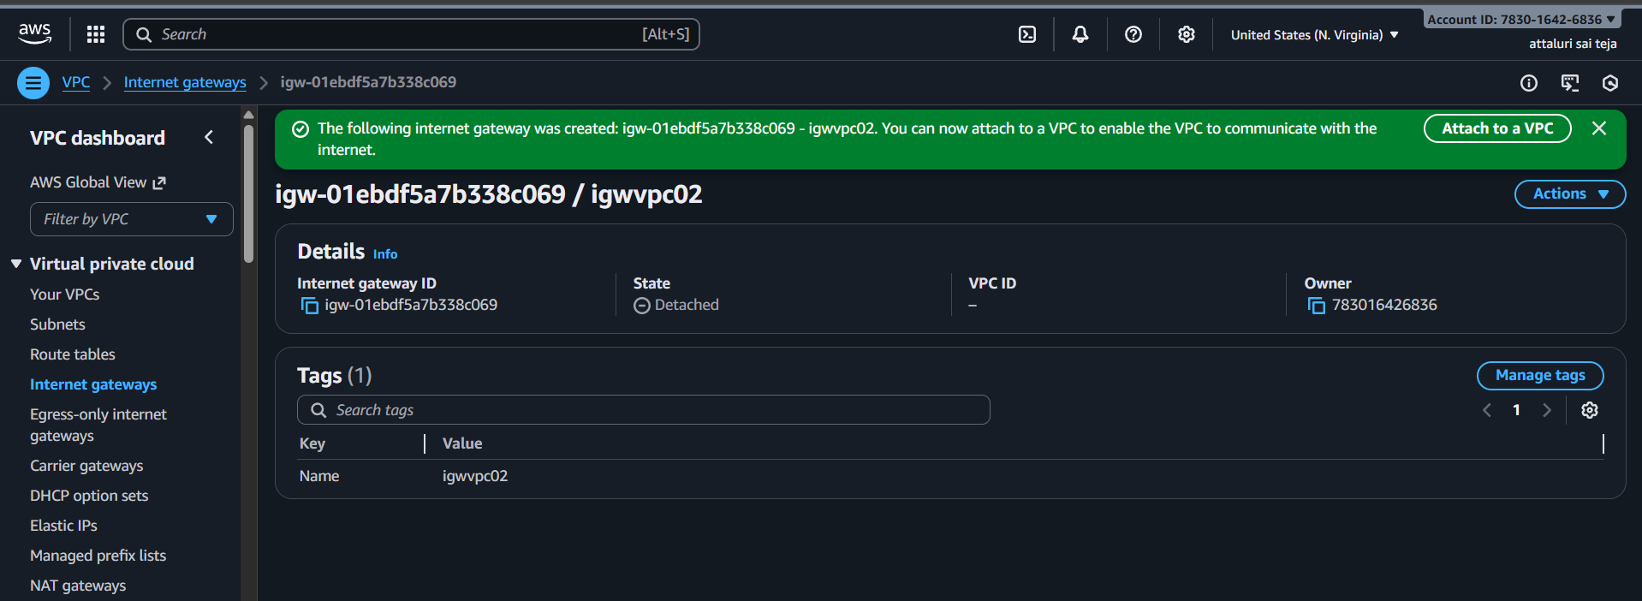
- Selected the vpc 02 and attached the vpc to igw
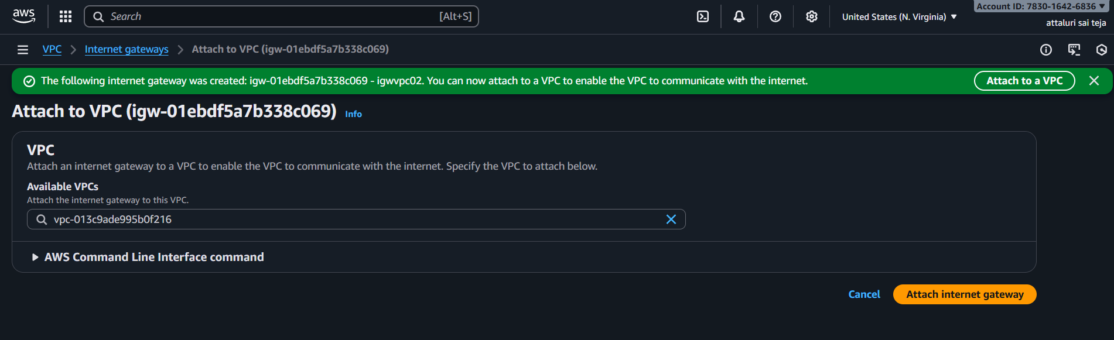
- Navigate to Routes table and select public route table and edit the route table
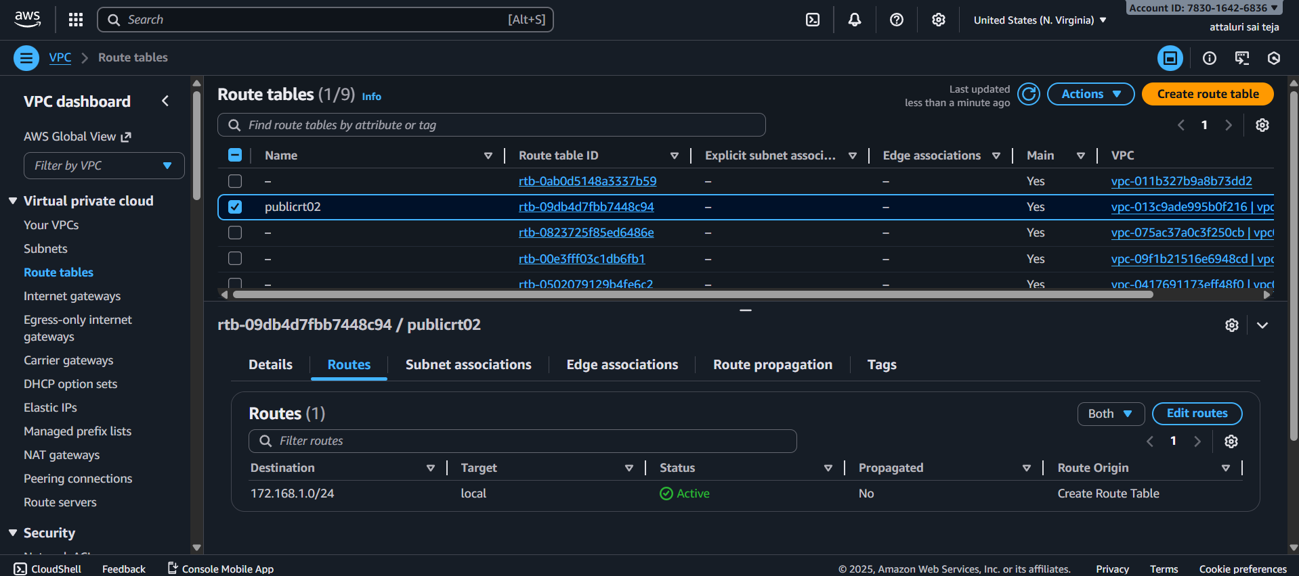
- Attach the igw into it
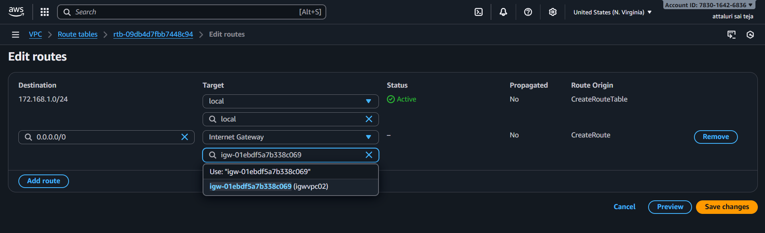
- Route Table has been updated
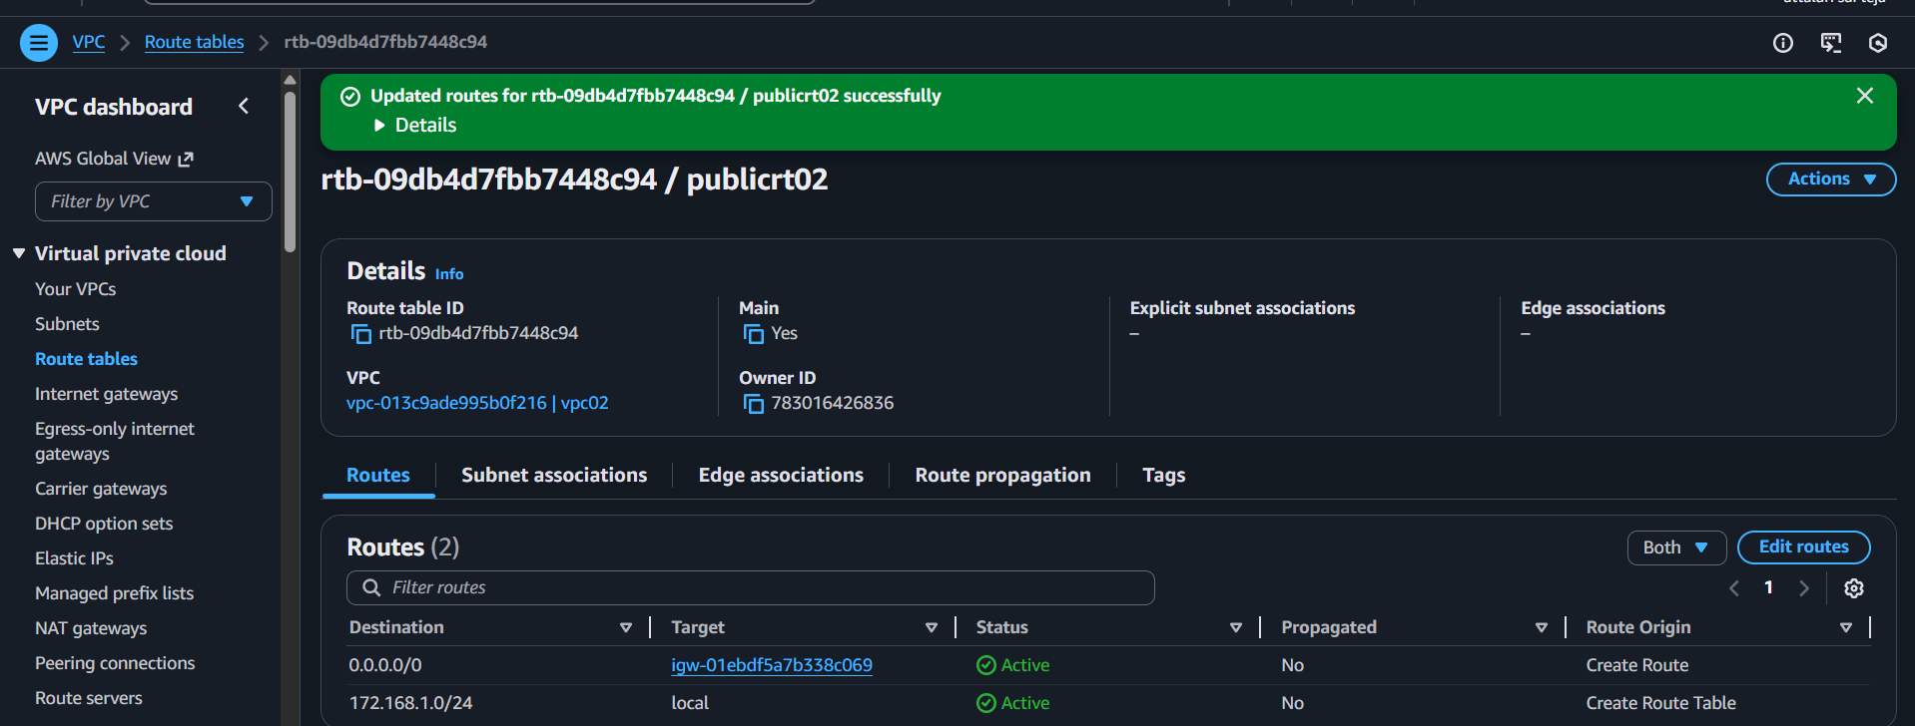

- Navigate to Subnet associations and attach public subnet
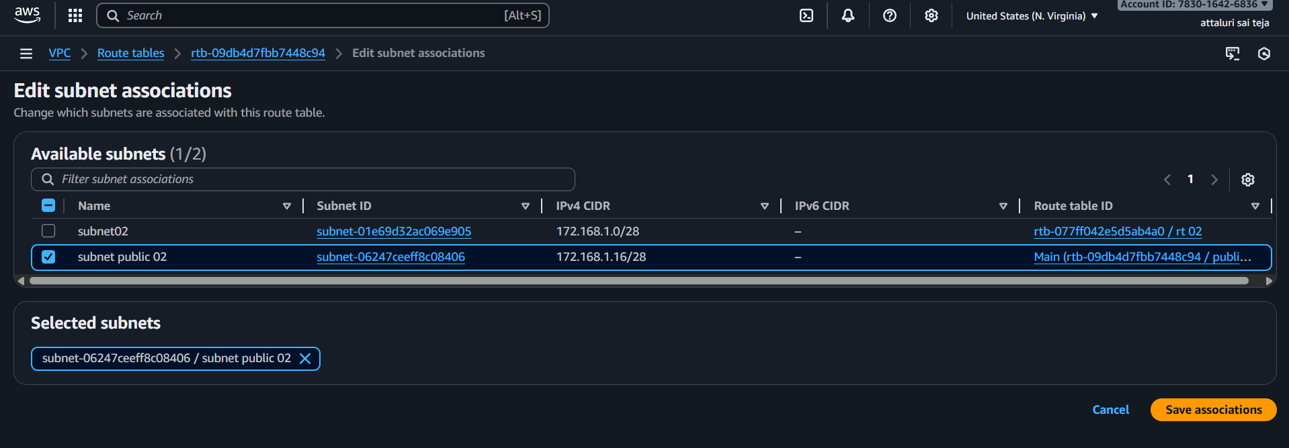
- Successfully Updated Subnet Associations
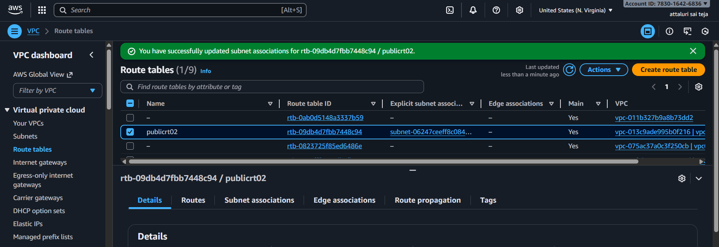
Step 5: Transit Gateway Attachments
- Now select Transit gateway ID which is created in previous step and next select attachment type vpc
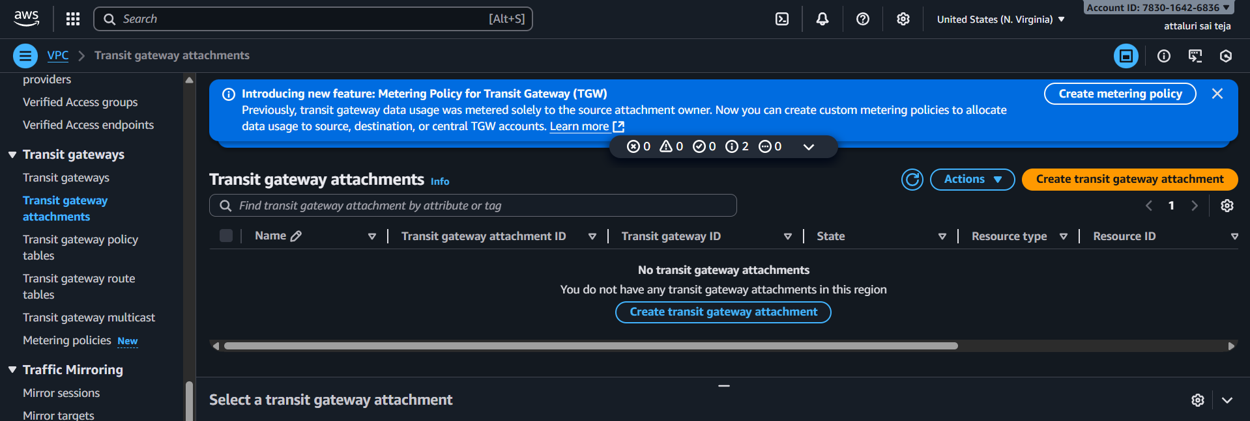
- VPC attachment: Select and configure your VPC attachment.
- VPC ID: Select the VPC1 to attach to the transit gateway.
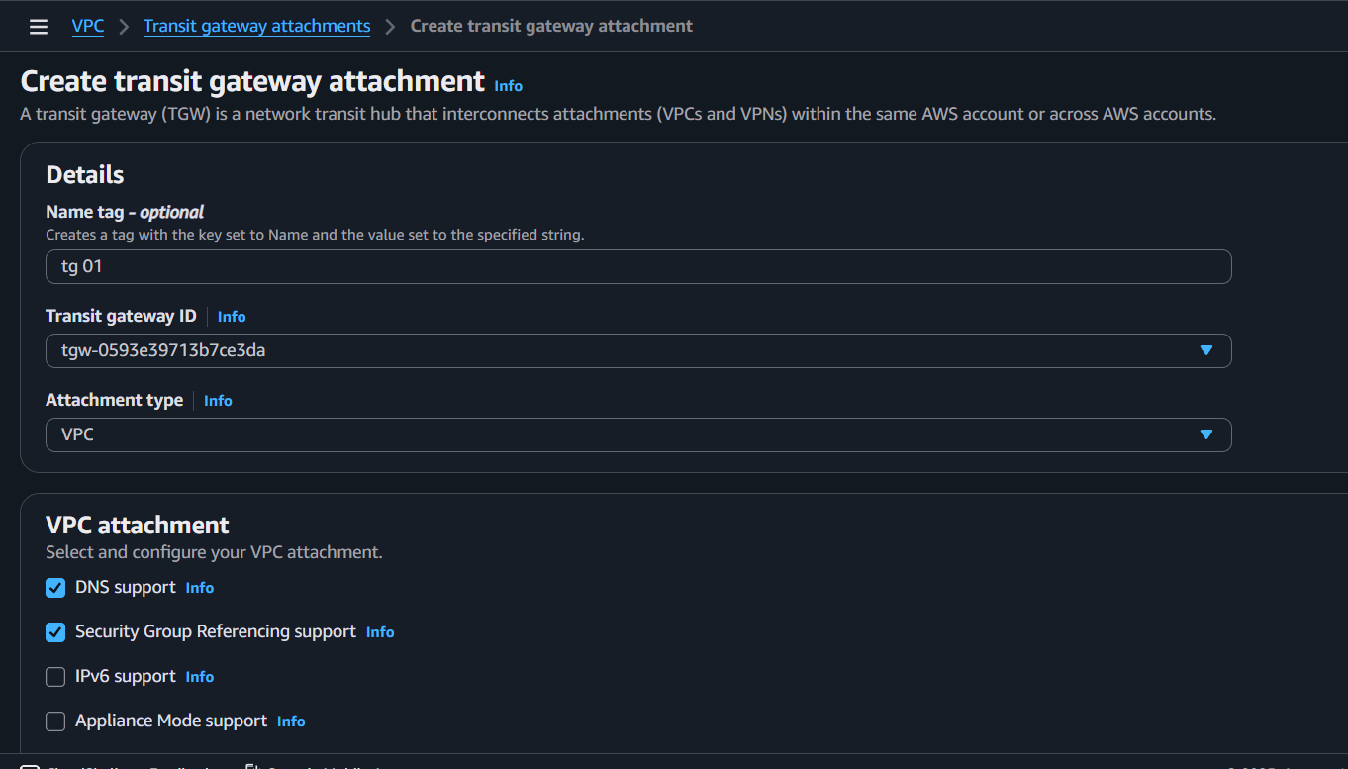
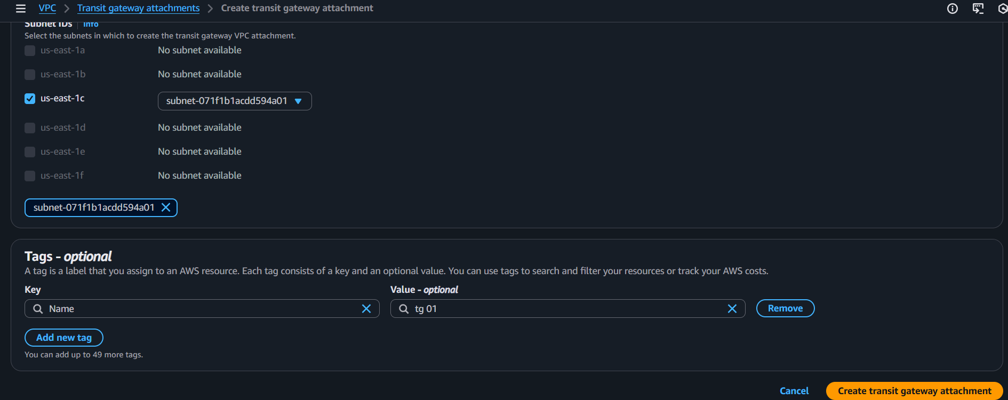
- Same we need to do on VPC2 as well.
- Here we see VPC1 and VPC2 are attached to transit gateway

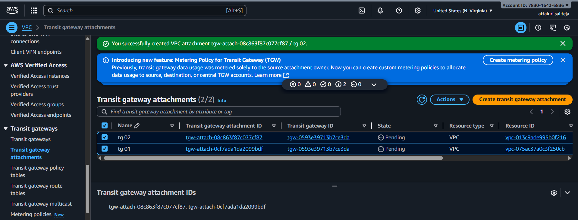
Step 6: Creating route Tables
- Navigate to route table section and create route table 1 for each vpc
- Click on create route table
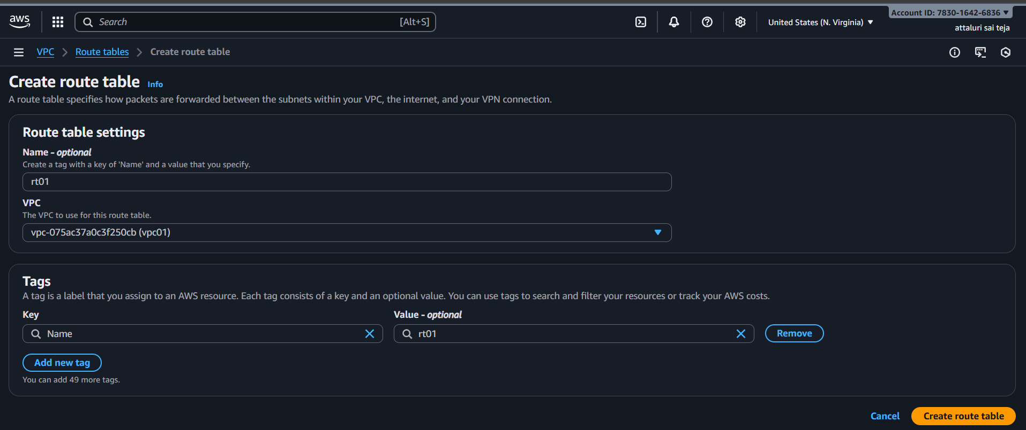
- Do the same for vpc2, vpc3 , vpc4
- Route table has been configured for each
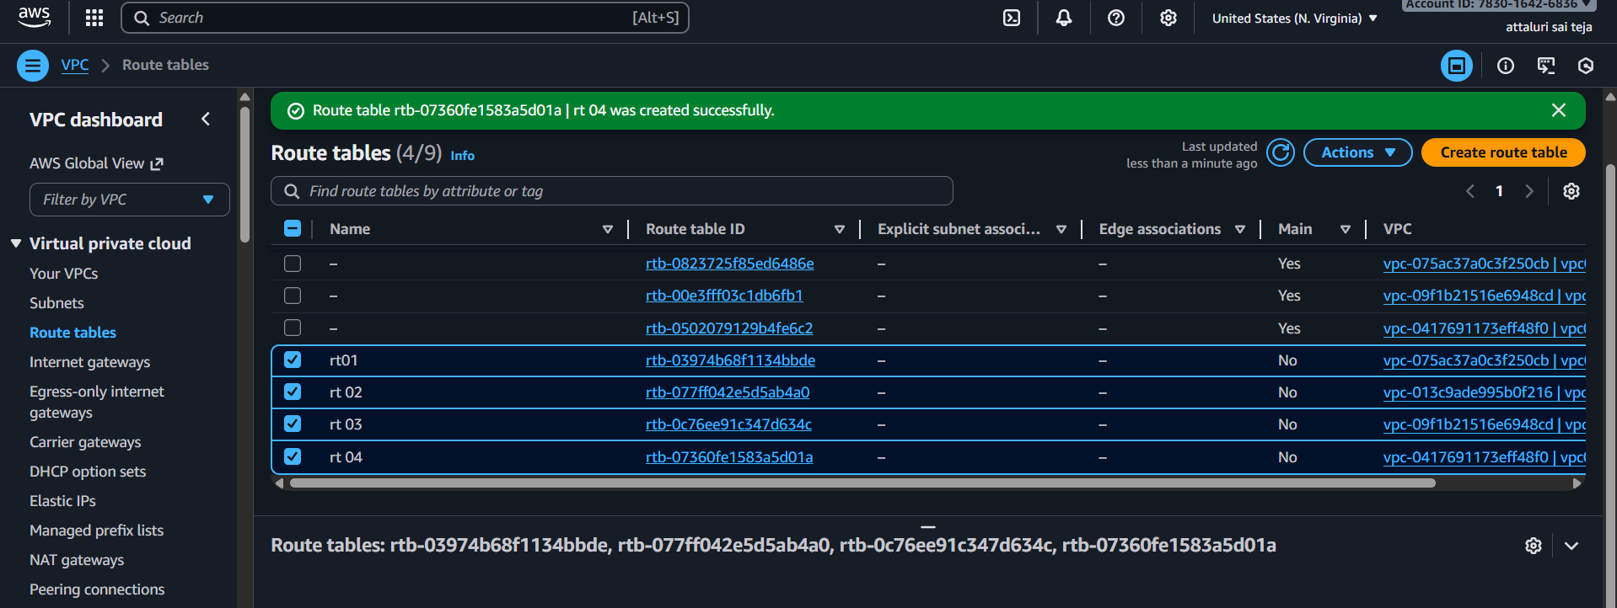
Step 7: Adding subnet associations in route table
- Navigate to route table and select subnet association tab and add each subnet association for each route
- Click on save association
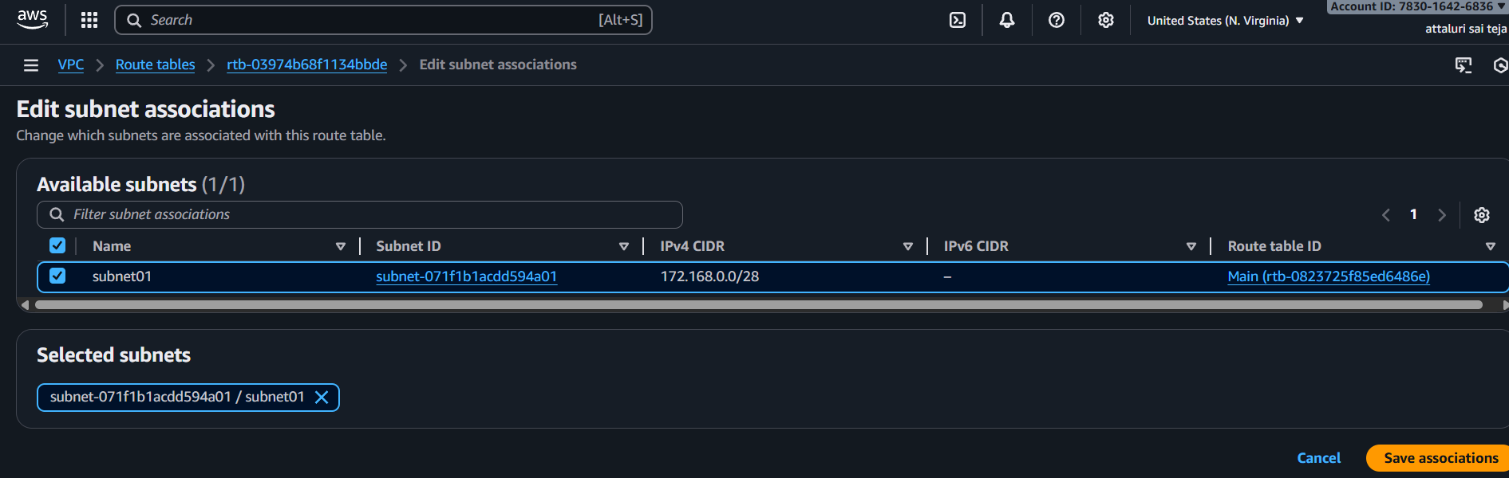
- Do the same for all vpc,s
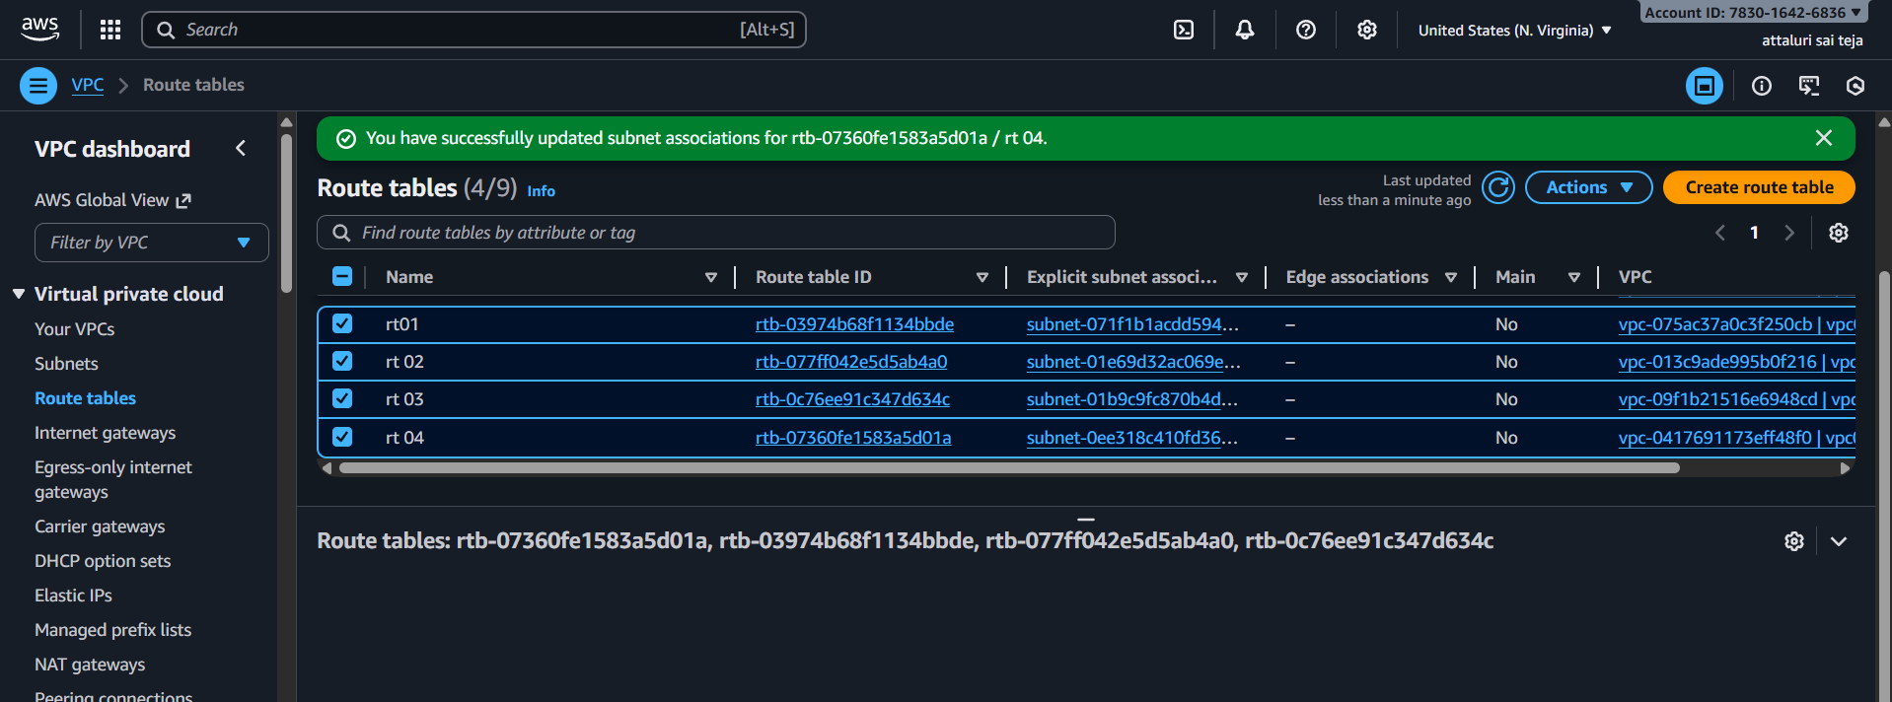
- Now choose route table and navigate to routes
- Click on Edit route and choose add route
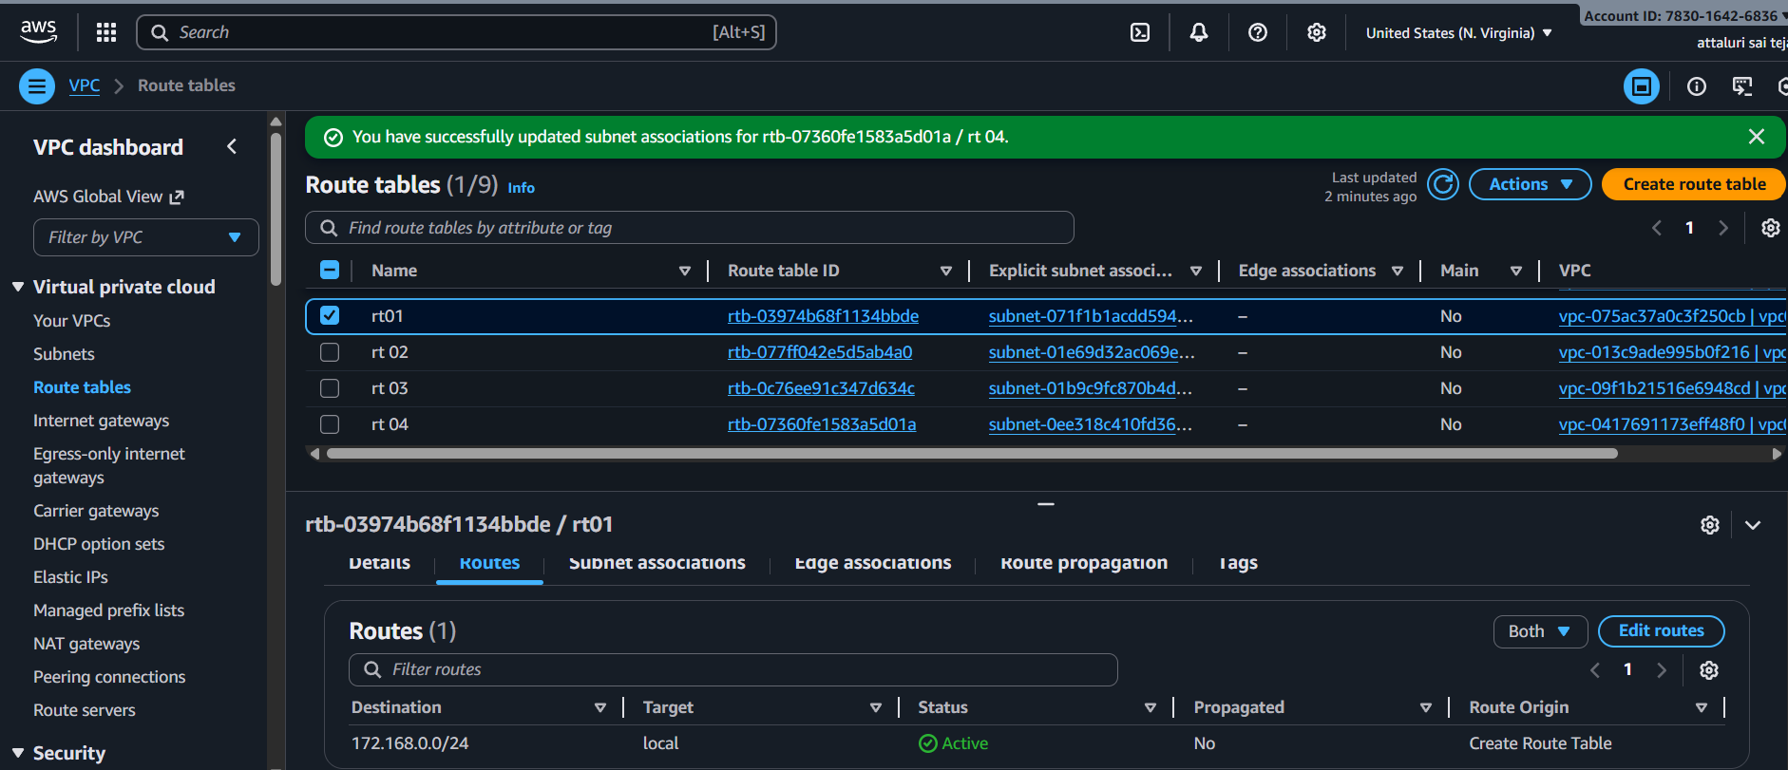
- Set CIDR block and in drop down box select Transit gateway and click save changes
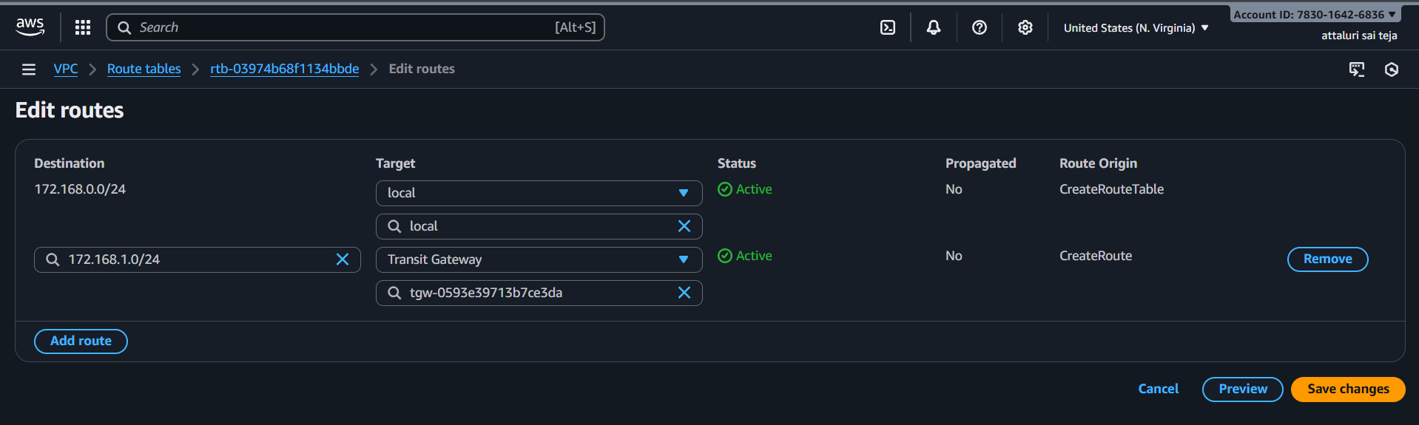
- Route table was updated
- Now same process we need to do for the VPC2 as well.
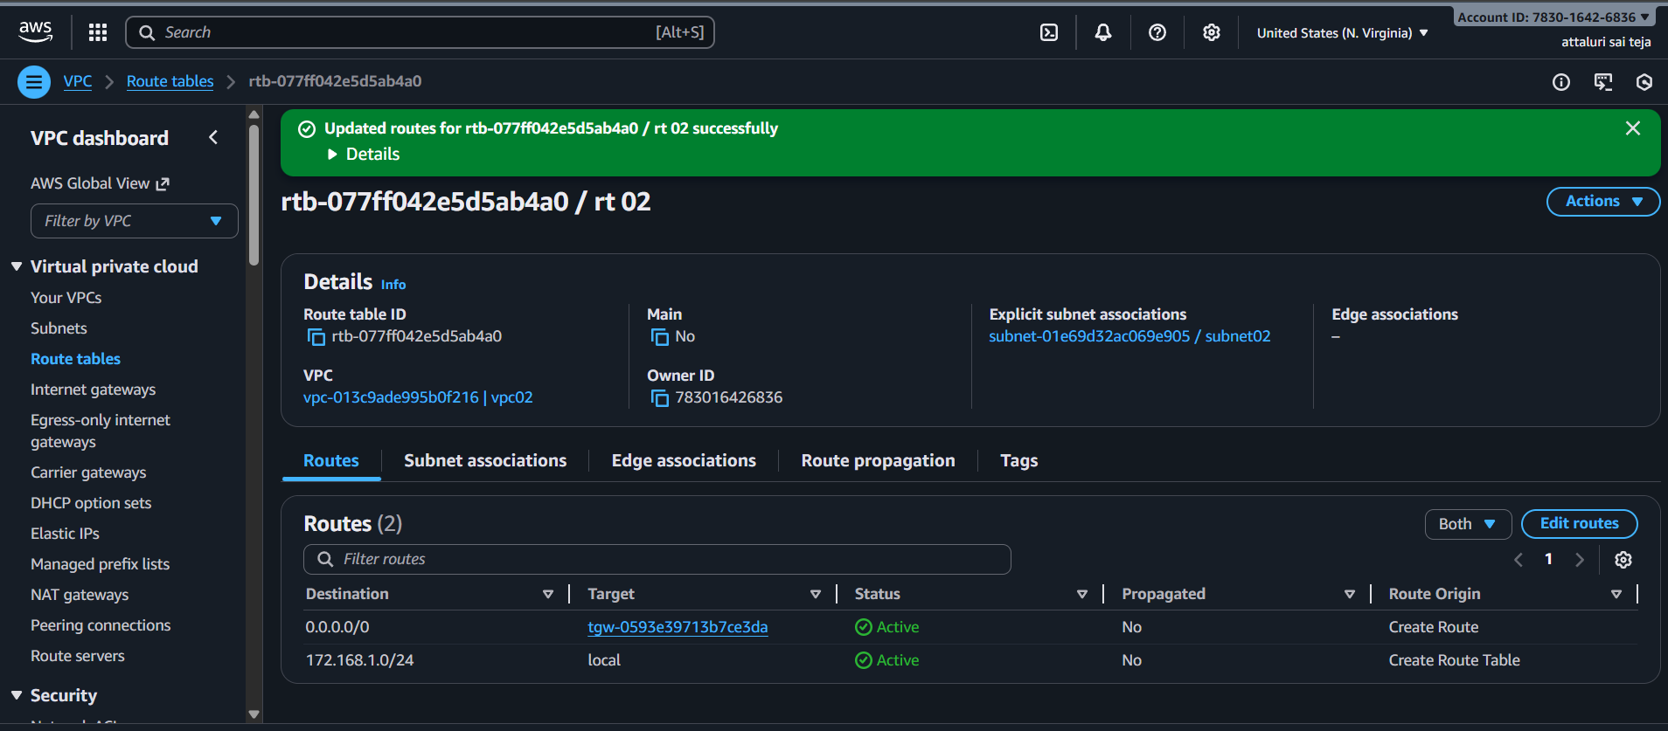
Step 8: Configuring security groups
- Create New Security Groups or select existing security group
- Now edit inbound rules to security groups allow all traffic
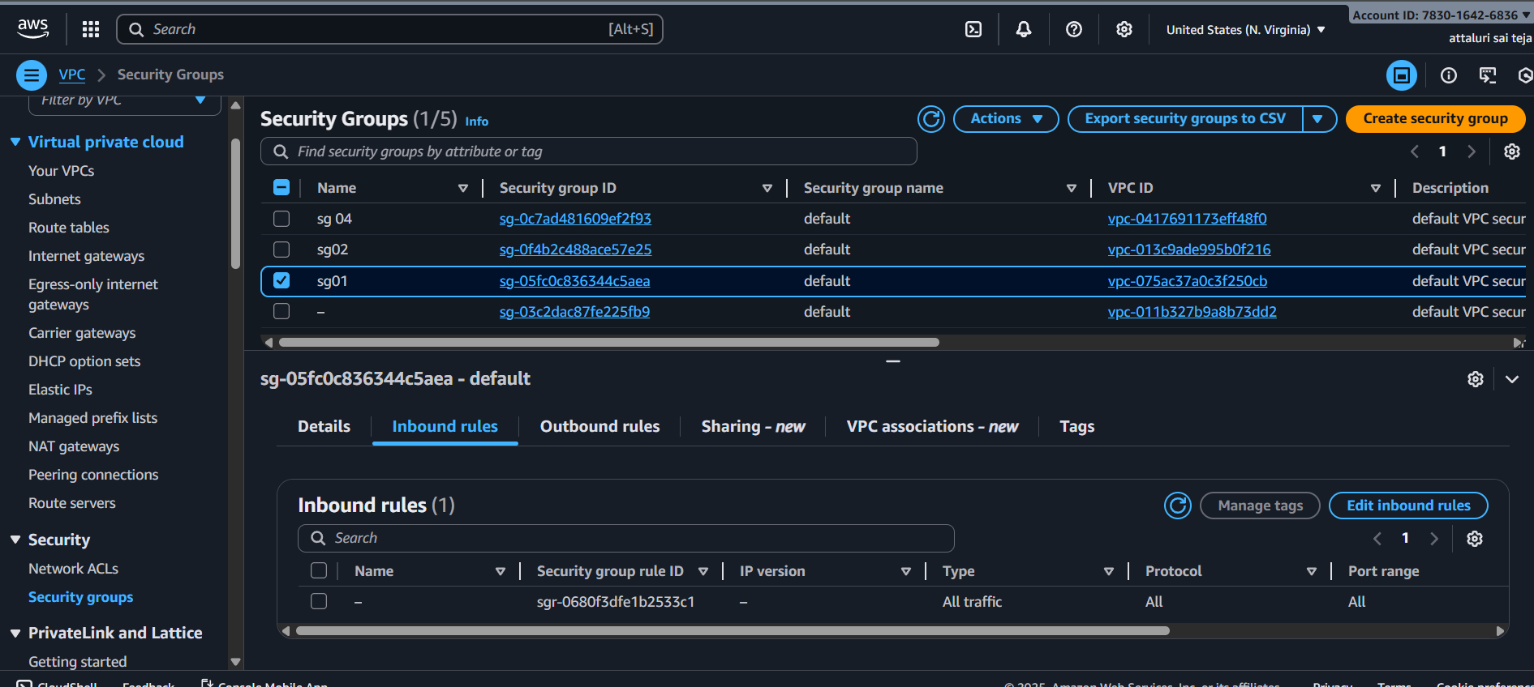

Step 9: Launch EC2 Instance
- While launching instances in network settings choose created VPCs and also choose private subnet as shown in below figure
Instance -01
- Launce the instance from the vpc one with the Private Subnet
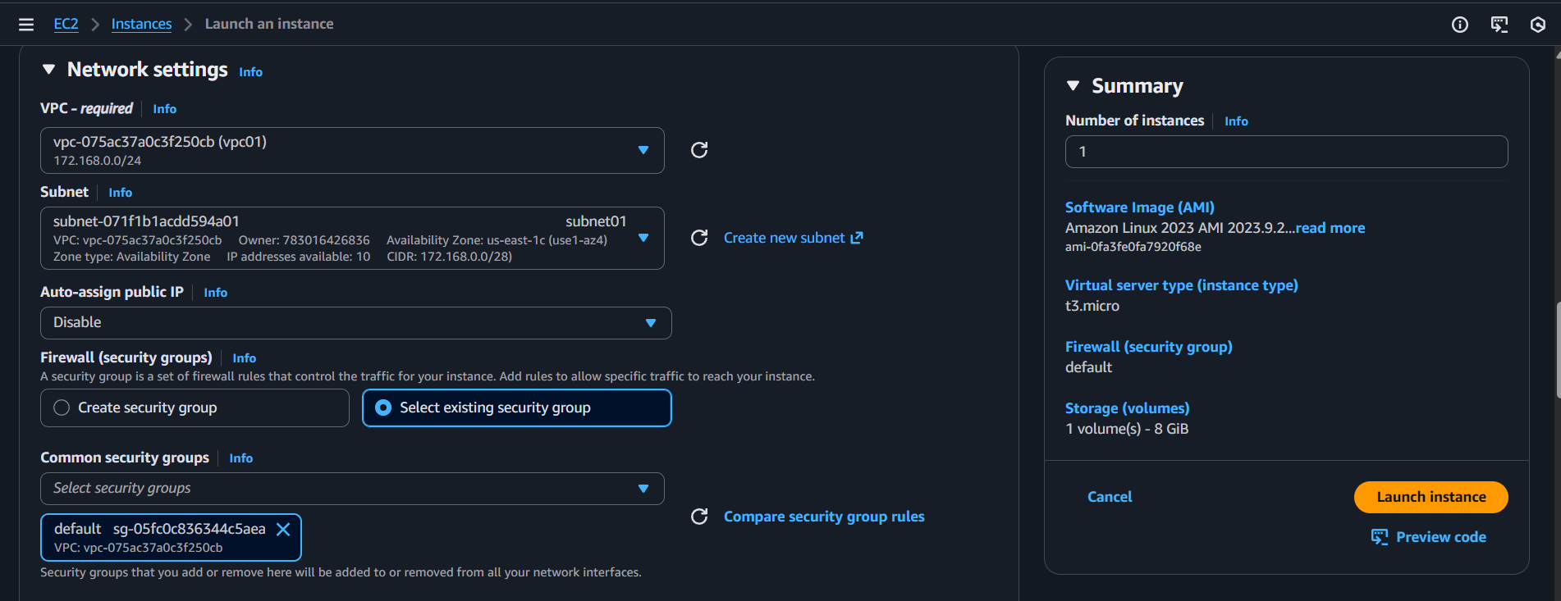
Instance -2
Launce the instance from the VPC two with the public subnet.
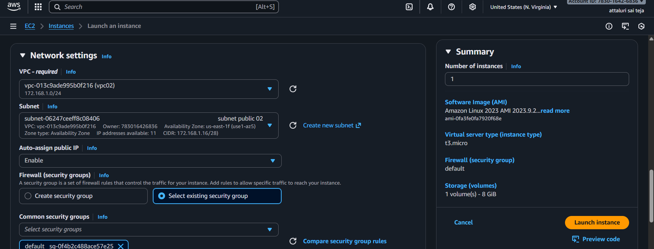
- Both EC2 has been Launched
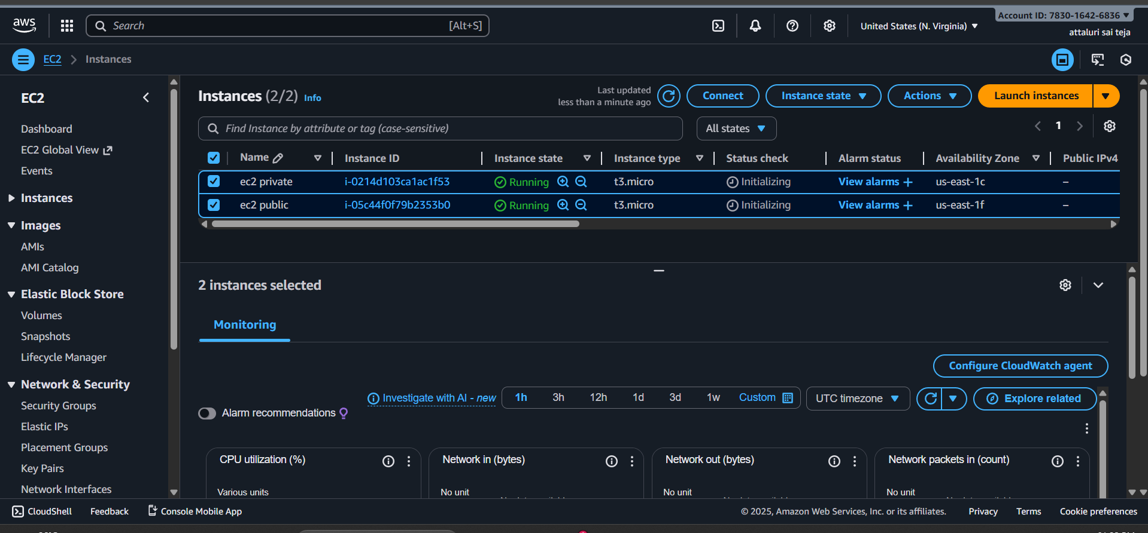
Now both EC2 instances in their respective VPCs are created.,
That is VPC1 and VPC2. They can communicate to each other with their private IPs through transit gateway
Step 10: Connect ec2 instance
- Connect Through Public Instance
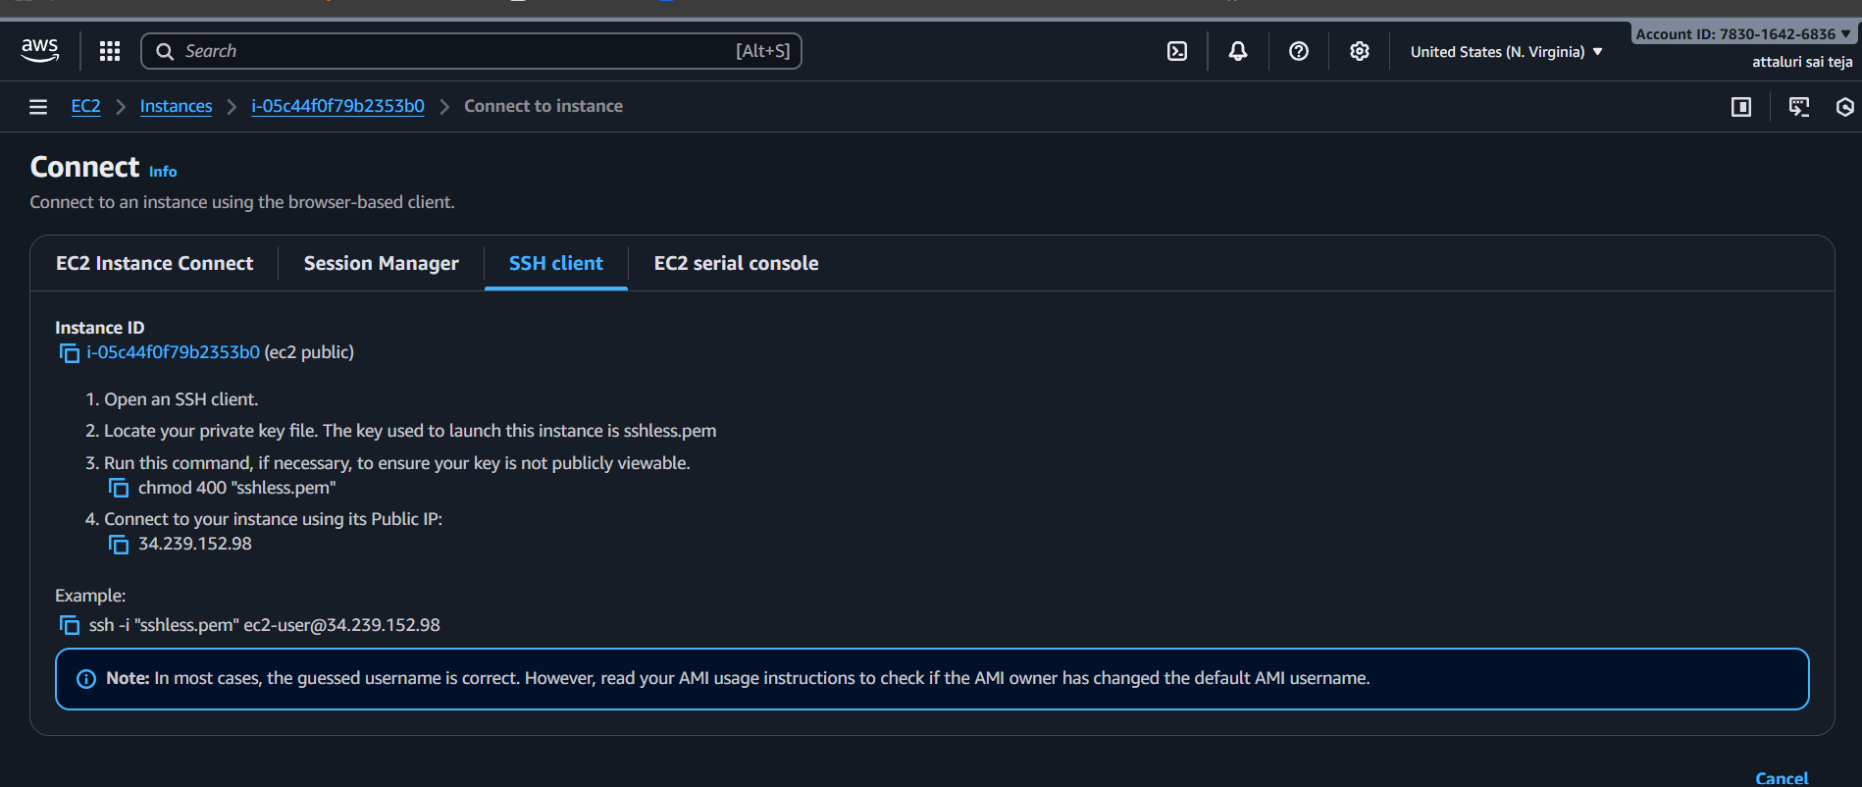
- Connected with Public Instance
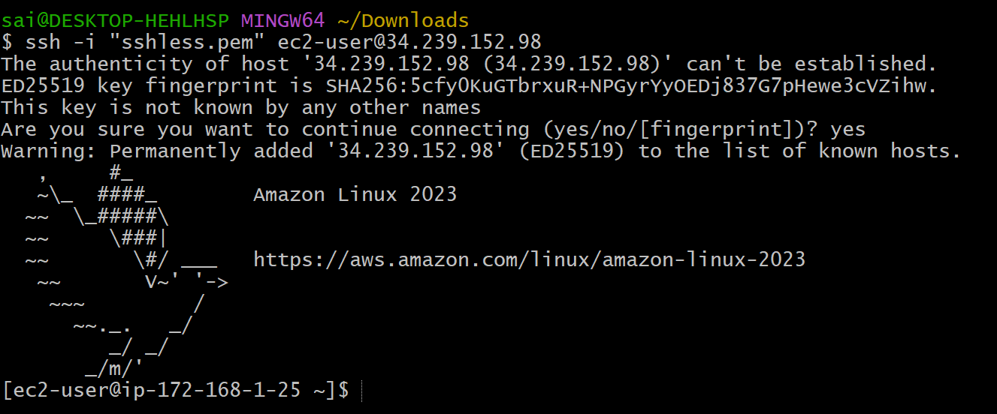
- Now securely copy the keypair .pem file to the desired path in the EC2 instance of VPC 1:
- And verified using ping@privateip of another instance

Here we see VPC 1 to VPC 2
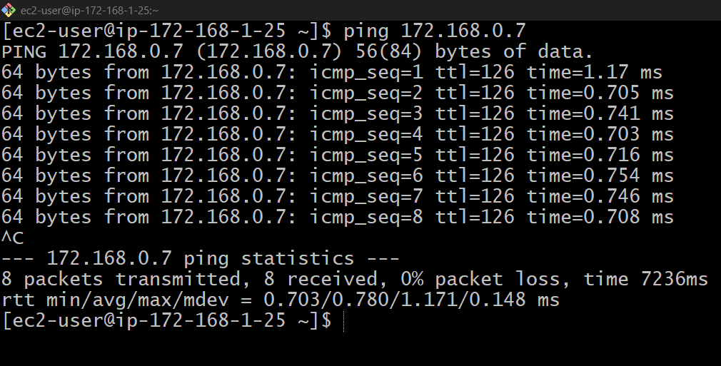
- Do the same process another vpc’s .
Here we see VPC 2 to VPC 1 and VPC3
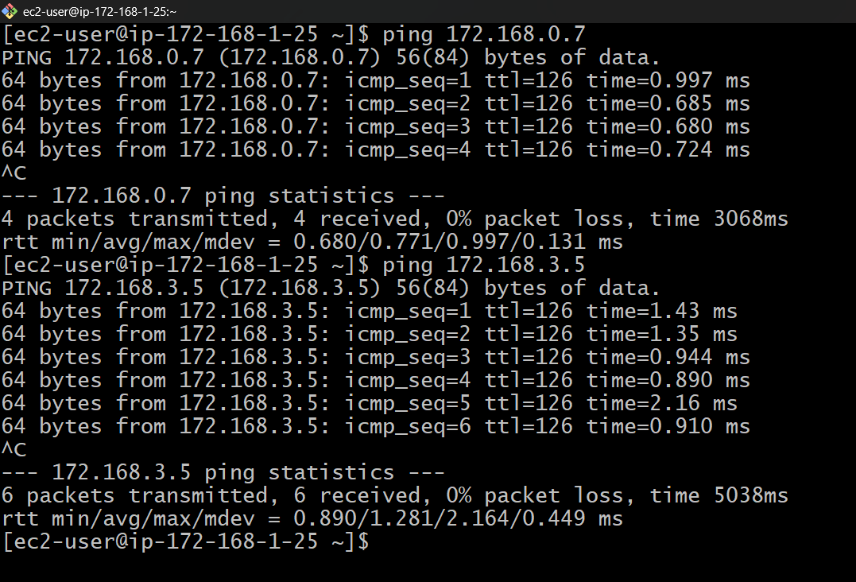

- Adding route table screen shots for reference
- Main vpc
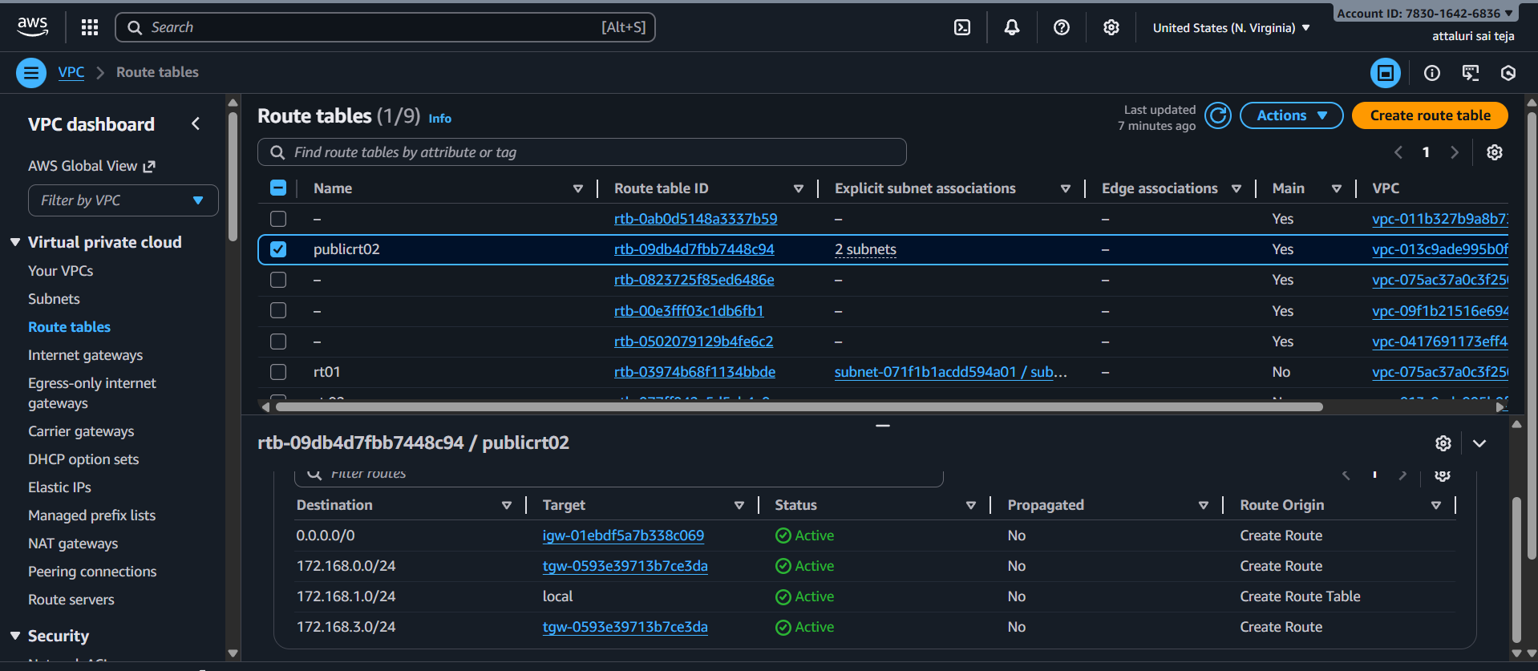
Vpc 03 route table
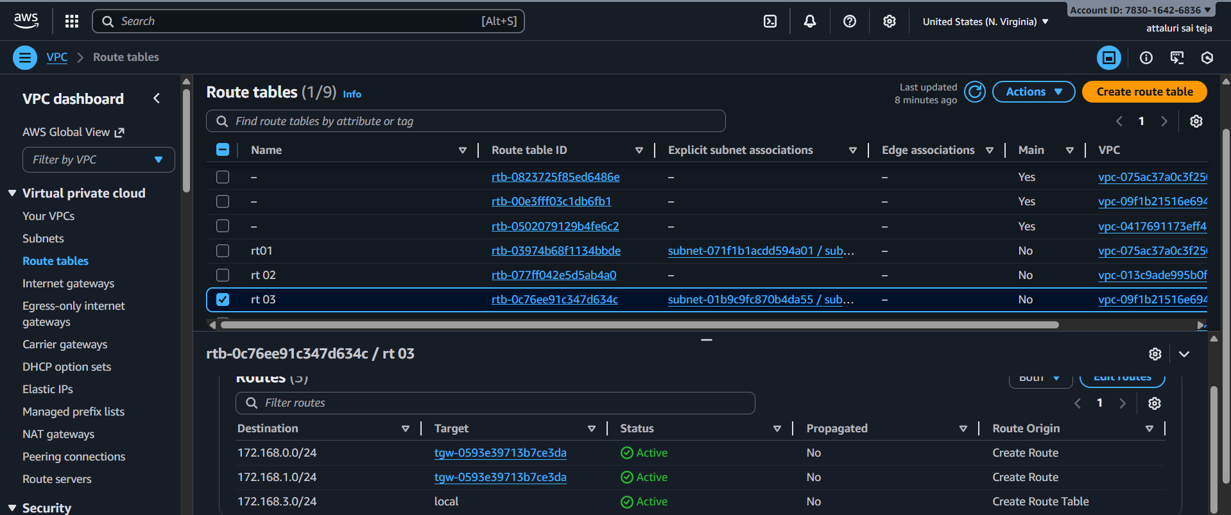

Security group of vpc 03 for reference
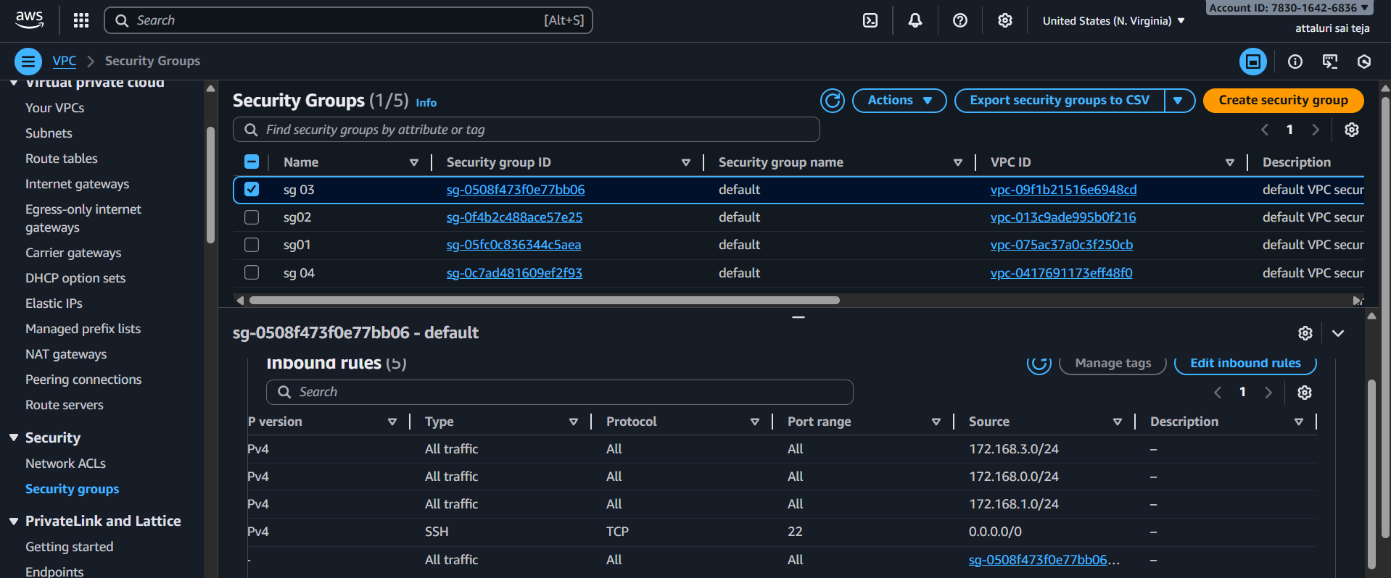

*NOTE* :
- Route table should be defined correctly
- Security groups of instances should be defined correctly
- CIDR should not be overlapped between VPCs
- CIDR of VPC 1 should be defined in VPC 2 and vice-versa
- In public subnet both tgw and igw are added
AWS Transit Gateway (TGW) is a central router provided by AWS.
It allows you to connect multiple VPCs, VPNs, on-prem networks, all in a scalable way
Transit Gateway = AWS’s big router for connecting multiple VPCs.
Ex:
Transit Gateway connects them the same way a home router connects devices inside a house.

Set up a VPC Endpoint.
In Company cloud environments, security and performance are the first preference. VPC Endpoints help in maintaining secure, private connectivity to AWS services without using the public internet.
Step 1: Navigate to AWS VPC Dashboard
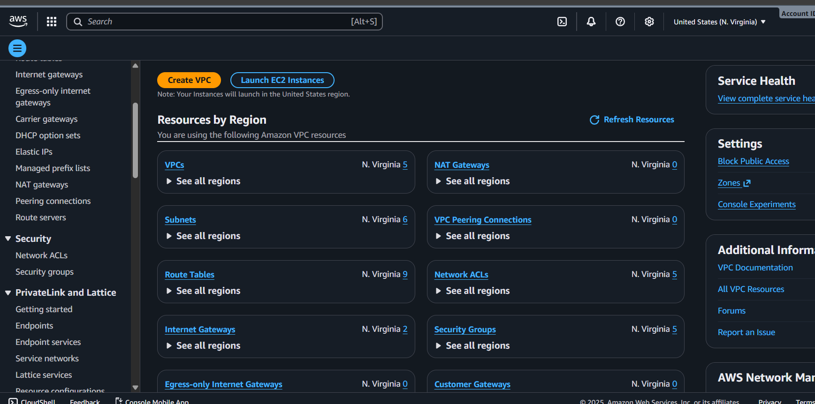
Step 2: Select Endpoints from the Navigation Panel
- In this VPC Dashboard, locate to the "Endpoints" option in the navigation pane.
- Choose the VPC Endpoints at the left panel. Click on Create Endpoint.
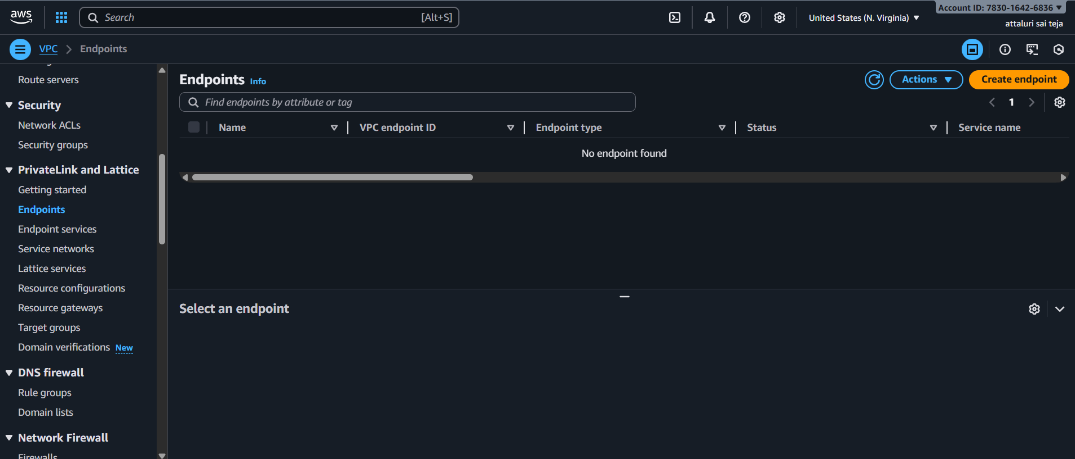

Step 4: Create Endpoint
- On Clicking on the create Endpoint button, it starts the creation process of endpoint.
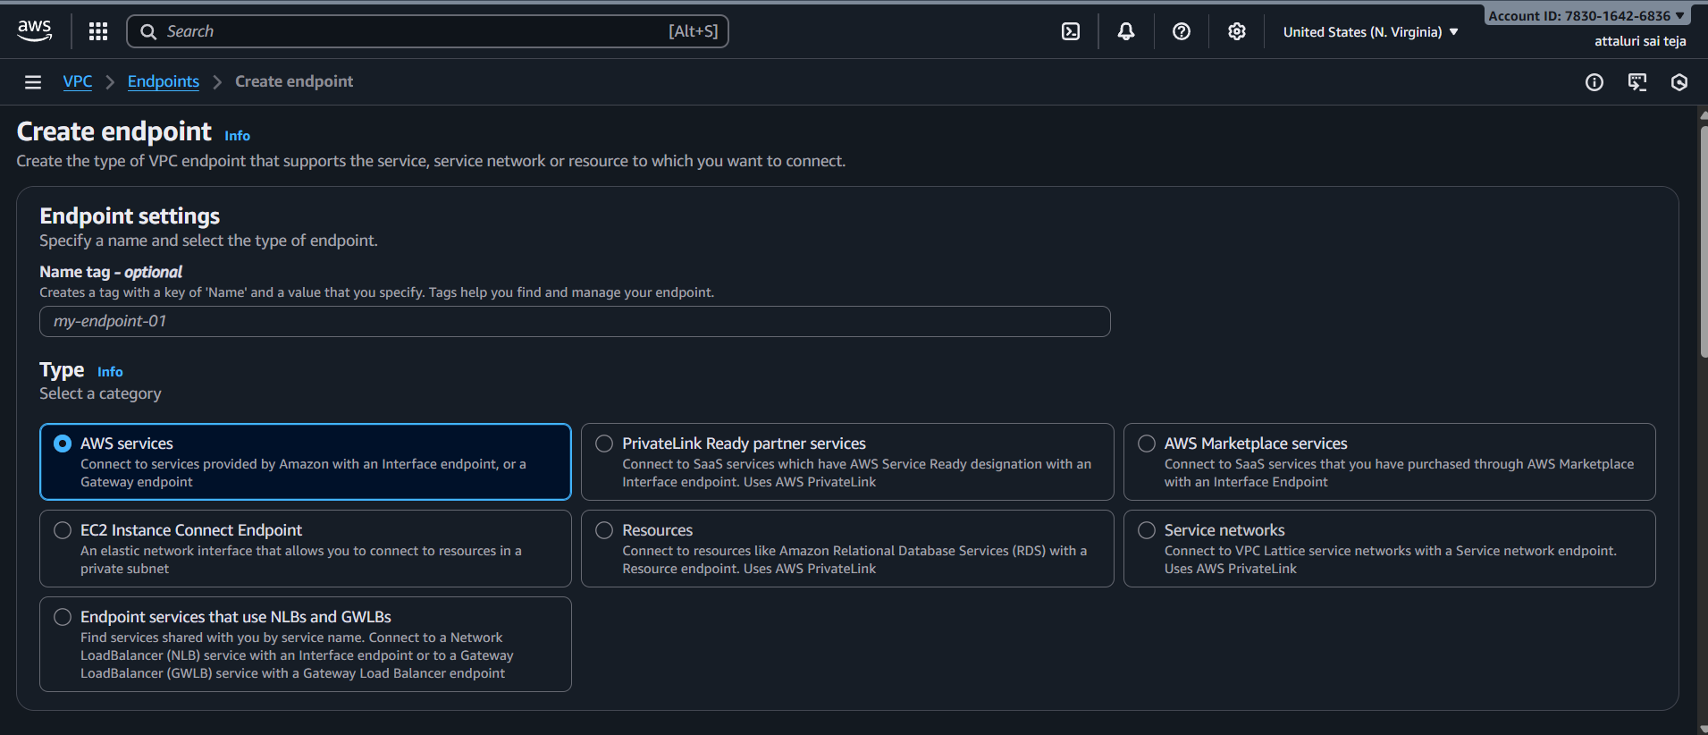
Step 5: Choose Service
- Select the AWS service for which you want to create a VPC Endpoint such as it can be any AWS Services like Amazon S3, AWS DynamoDB or others. Here we are choosing Amazon S3 in particular " com.amazonaws.ap-south-2.s3 "
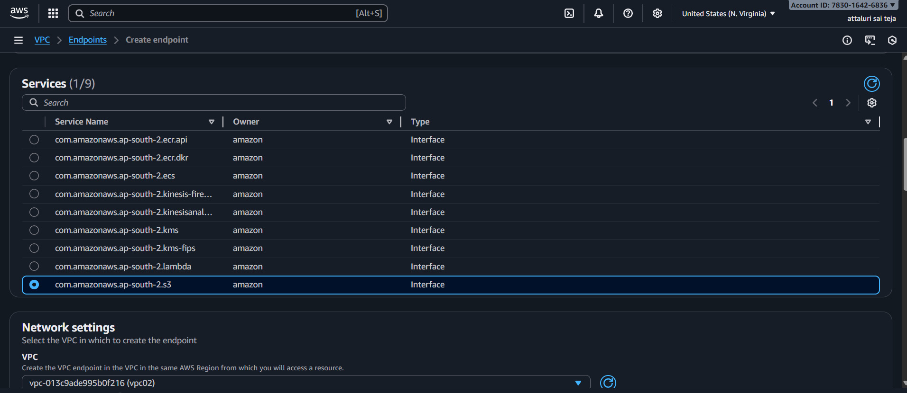

- Select the Vpc in network settings and enabled the DNS
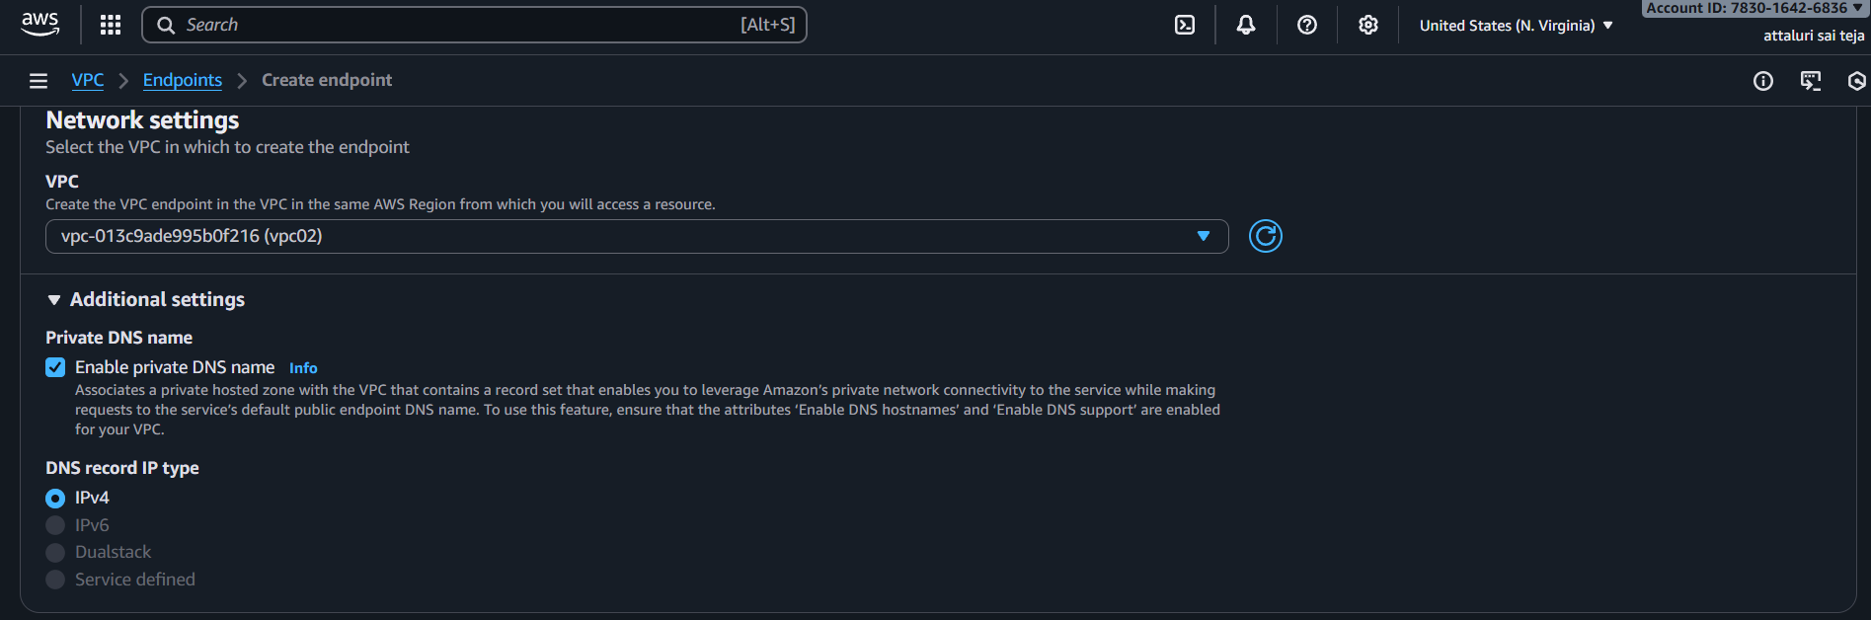
- Select the subnet and ip version
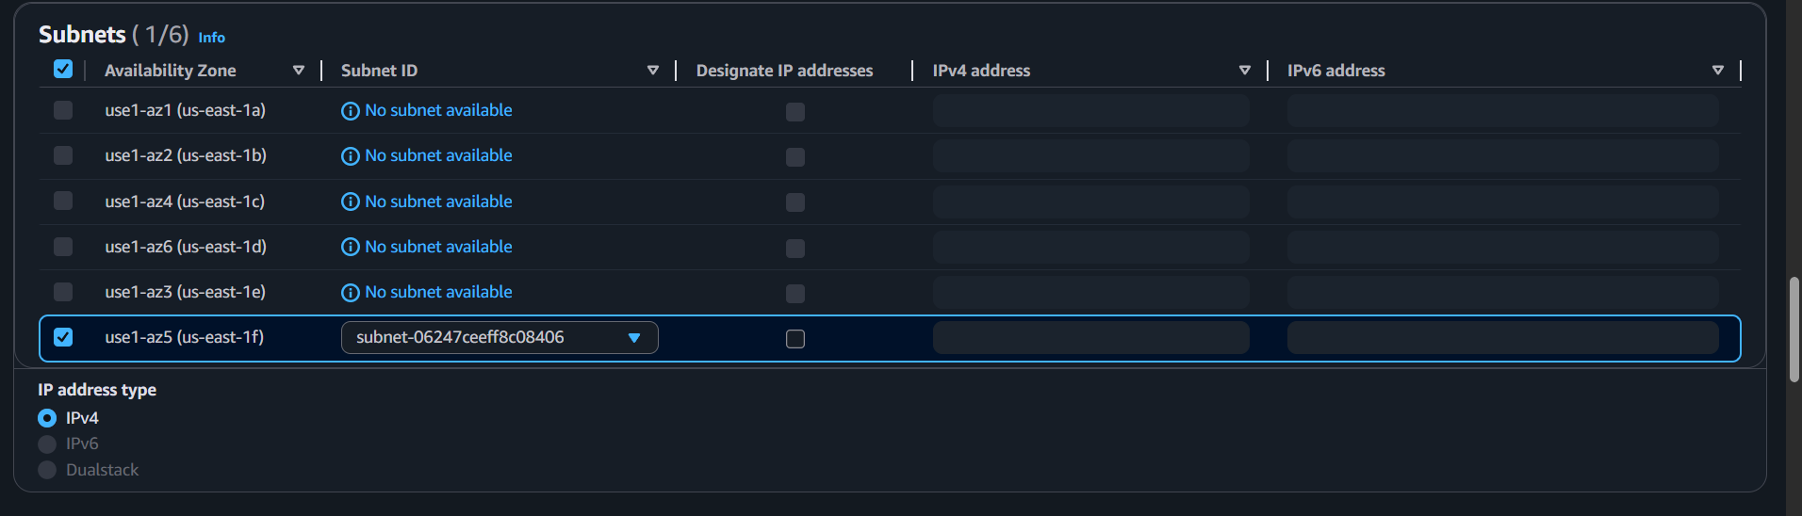
- Select the segurity groups as default and provide full access for policy section
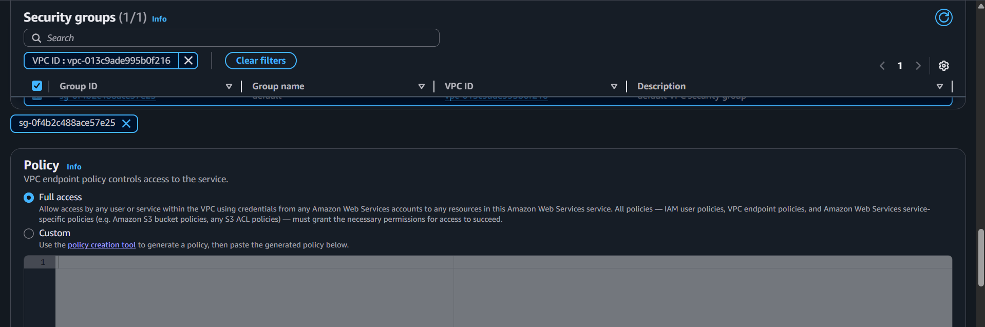

- Create End point by selecting the option
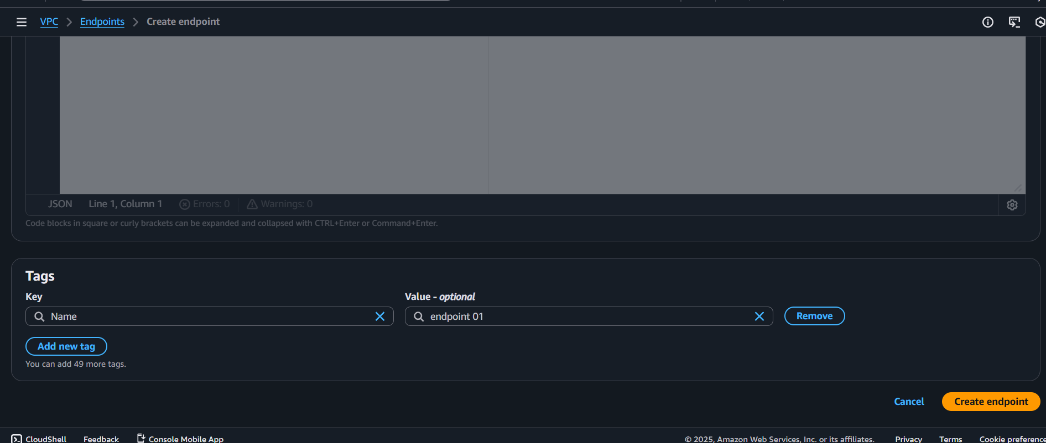
- Created END Point Successfully
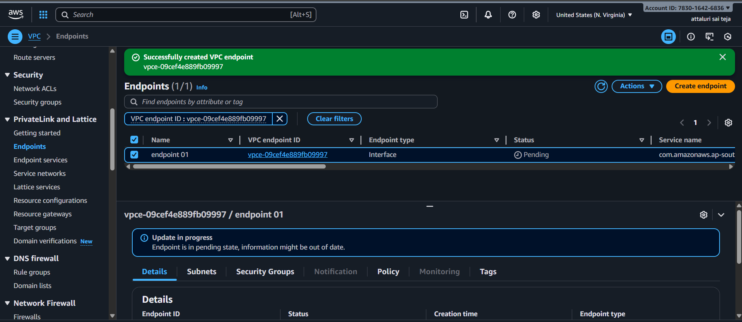
Verify Endpoint Creation
- Once the endpoint has created, verify its status in the Endpoints dashboard. It should shows as "Available" if the creation was successful.
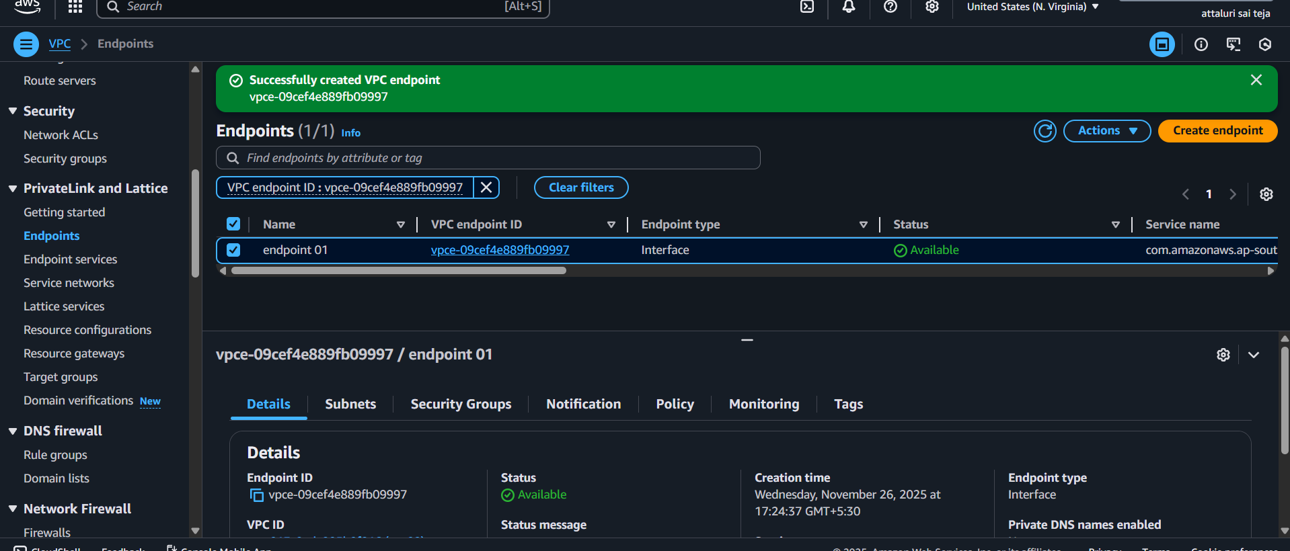
Create access key and paste under CLI Using aws configure
